FAMIECARE MOBILE APPLICATION

(BY SEMESTER-V OF III YEAR M.Sc.(CA&IT) 2022-2023)

Submitted By: -

(1) Varshil Shah (3067)

(2) Aman Sheth (3068)

Group Id: - 38

Company Name: - DATAHAY INFOTECH LLP.

Date of submission: - 24/04/2023

Submitted To: -

K. S. School of Business Management

MSC In Computer Application and Information Technology,

Gujarat University.



Acknowledgement

* It Was A Great Experience Working On The Project Of “Famiecare Mobile Application”. We Express Our Gratitude Towards Who Were Constantly
* Involved With Us During Our Project. We Will Always Occupies A Special Place In Our Heart, Throughout Our Career, For Both Personal And Professional Reason.
* Whenever A Technical Project Is Developed, Eventually. It Requires To Technical Environment And Technical Guidance To Get Involved In The Assigned Project Enthusiastically. We Also Grateful To “Datahay Infotech LLP” For Being Extremely Friendly And Co-Operative During Entire Course Of Our Project.
* Their Continuous Help And Support Made The Project Much Easy. There Is No Exact Word To Express. Our Regards And Legitimate Gratitude To One Of Our Esteemed Techno Personality, Without Him This Project Could Not Get An Entrance Towards The Execution.
* I Wish To Express Our Sincere Thanks To All Our Friends For Their Kind Co-Operation And Moral Support. Once Again, I Thank One And All Who Had Helped Us Directly Or Indirectly In The Successfully Completion Of The Project.

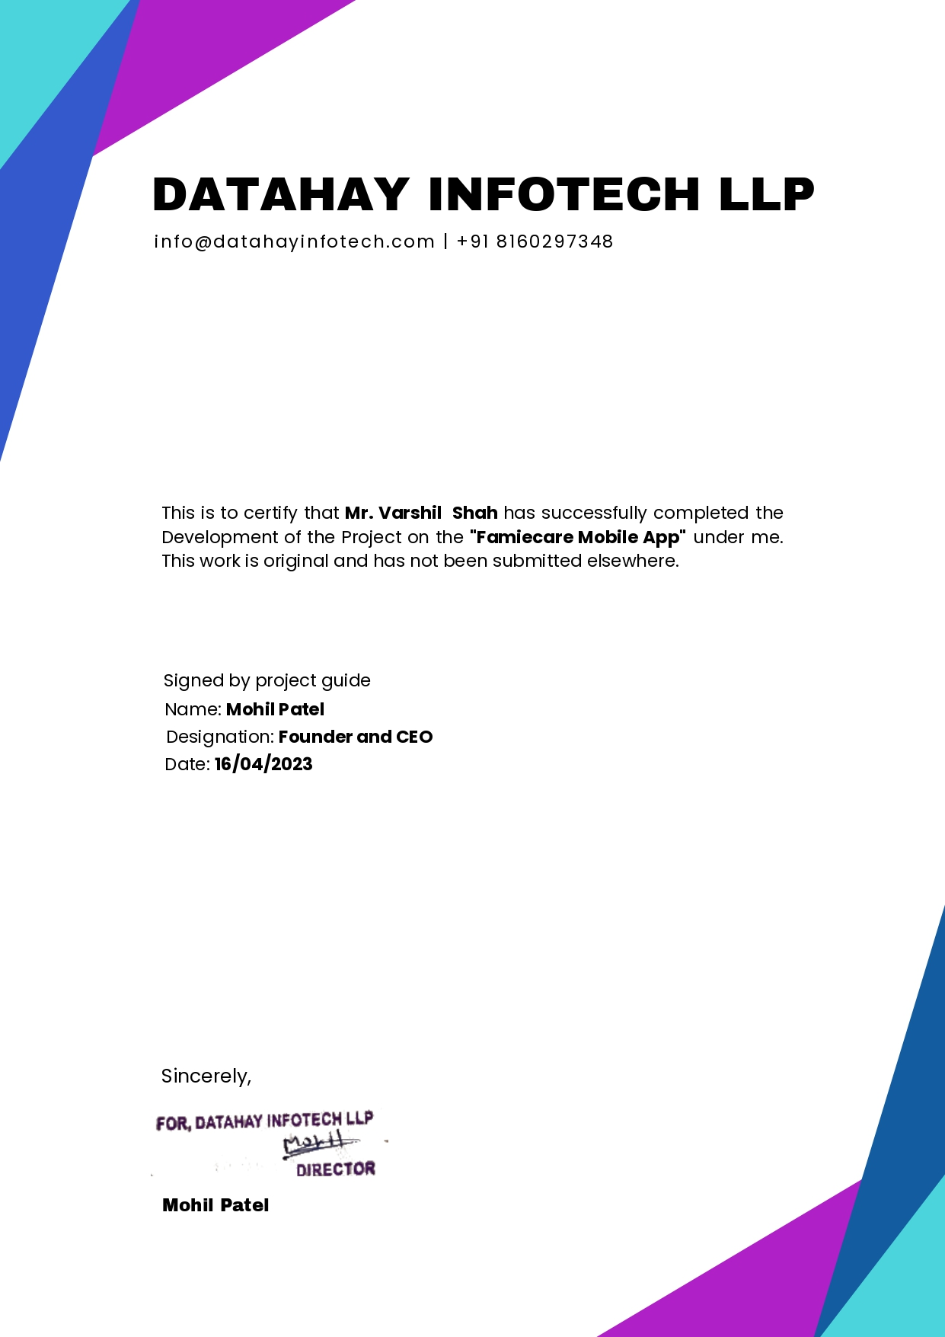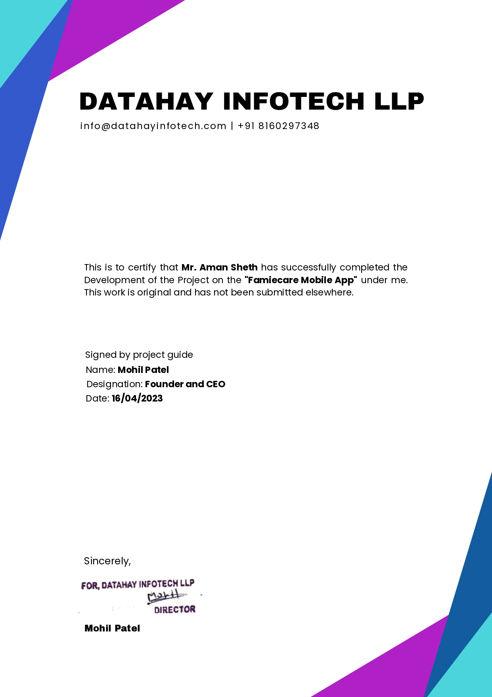

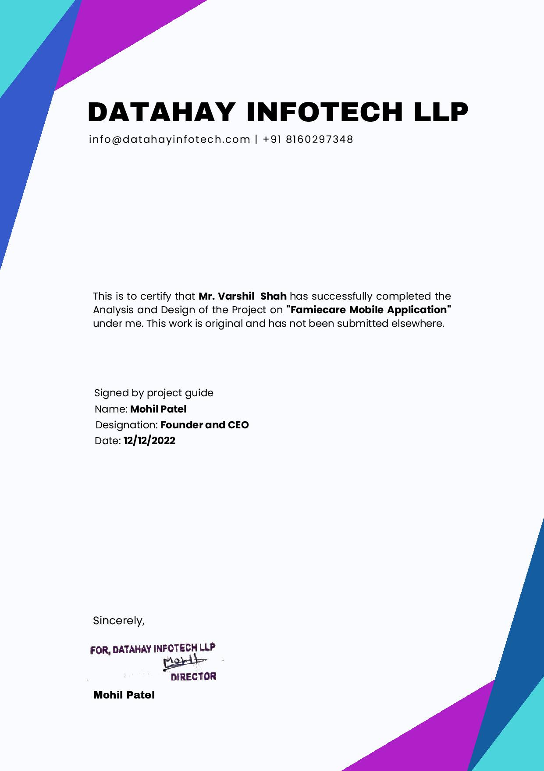

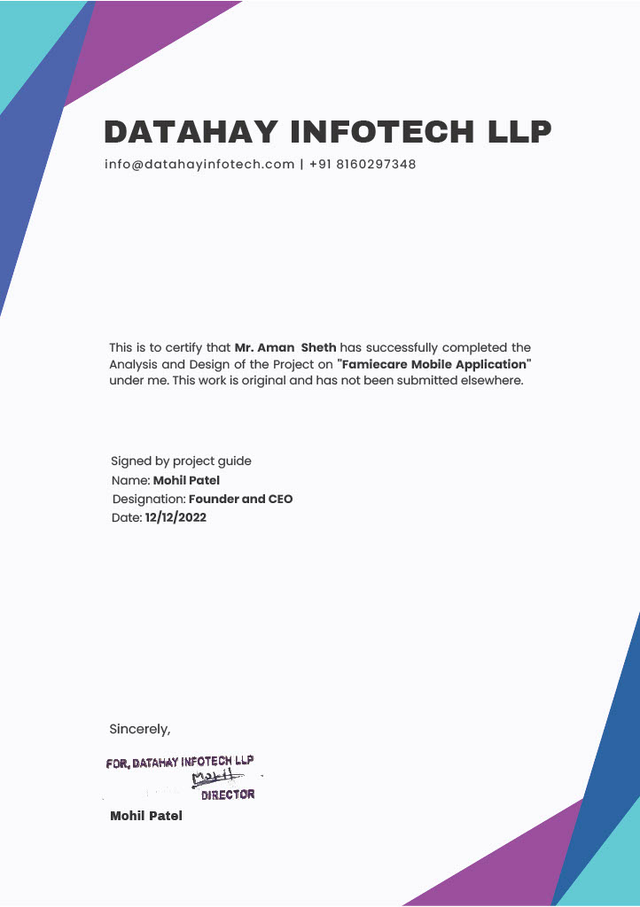

Index

Contents

1.0 Introduction: - 9

1.1 Organization Profile: - 9

1.2 System Detail: - 10

1.2.1 Existing System: - 10

1.2.2 Proposed System: - 10

1.3 SCOPE OF SYSTEM: - 10

1.4 Objectives: - 11

2.0 Proposed System Requirement Gathering 12

2.1 Stakeholder of System:- 12

2.2 Requirement Gathering Technique Used:- 13

2.3 CONSOLIDATED LIST OF REQUIREMENTS: - 14

2.4 PROJECT DEFINITION 14

3.0 SYSTEM MANAGEMENT AND PLANNING 15

3.1 FEASIBILITY STUDY 15

3.1.1 Technical Feasibility: - 16

3.1.2 Operational Feasibility: - 16

3.2.3 Economic Feasibility: - 16

3.2 Hardware and Software Requirements: - 16

➢ Software Specifications: - 16

➢ Hardware Specifications: - 16

3.3 System Planning: - 17

➢ Work Breakdown Structure:- 17

➢ Gantt Chart:- 19

3.4 Process Model: - 19

4.0 System Analysis And Design:- 21

4.1 UML(Unified Modeling Language) Diagram:- 23

➢ Use Case Diagram:- 23

▪ For User:- 23

➢ Class Diagram:- 26

➢ Activity Diagram:- 27

▪ For User:- 27

➢ Sequence Diagram:- 30

4.2 System Flow Diagram:- 33

4.3 Data Dictionary:- 37

4.4 User Interface:- 45

● Sign-In Page:- 45

● Sign-up Page(1):- 46

● Sign-up Page(2):- 47

● Home page:- 48

● Payment:- 49

● Admin Panel:- 50

❖ LIMITATIONS:- 50

❖ BIBLIOGRAPHY:- 51

❖ EVALUTION FORM 51

5.INPUT OUTPUT DESIGN 53

➢ Admin Panel 57

6.Testing 58

7.Summary 60

7.1 Assumptions 60

7.2 Limitations 60

7.3 Future Scope 60

7.4 Conclusion 60

EVALUTION FORM 61

# 1.0 Introduction: -

* We are developing application for making human life easier and reduce their workload especially for the woman at initial level.
* The role of our app is that women are having hectic morning and they have To do a lot of work, so this app is made To give them relief, in which they have everything on their door for which she needs To go outside.

# 1.1 Organization Profile: -

* About: -
* Datahay Infotech LLP is established by young entrepreneur with the dream of providing software and web solutions with best quality. Currently it is in Ahmedabad based city and on the path of growing.
* Datahay Infotech LLP provides best services regarding IT Solutions like, all types of Designing and Development, Social Media Marketing and Branding, Provide guidance in Firm Registration and other Legal Process for New Start-up.
* Company Name: - Datahay Infotech LLP.
* Address: - 400/2211 G.H.Board nr. Navlakha Bungalows Bapunagar Ahmedabad, Gujarat-380024.
* Email: [info@datahayinfotech.com](mailto:info@datahayinfotech.com)

# 1.2 System Detail: -

## 1.2.1 Existing System: -

* As we mentioned above for delivering item on online there are big basket and so many website/applications are using. but some of the limitation of this websites/application such as fresh product is Not provided sometimes, it takes more time To deliver and so many more. so, we are making a new mobile application for try To overcome this limitation of Today’s present mobile application.
* Here below present some of the limitation which is find or recognize by ours which is as follows.

1. In existing system, they are delivering Not a fresh product which is near expire Date.
2. Usually, warehouse location and the delivery location are in different area so that it takes more time To deliver the product also they are stuck in traffic and sometimes other factor like: heavy rain etc. affects the time of delivery Too.

## 1.2.2 Proposed System: -

* As we mentioned above, we find some of the limitation of existing old product delivering system and that’s why we inspire To make one mobile application which is try To overcome this limitation and we make it more secure and realizable and qualitative output.
* Here below present some of the advantages which we focus To satisfy in our system which is helpful To overcome existing system limitation.

1. The role of our app is that women are having hectic morning and they have To do a lot of work, so this app is made To give them relief, in which they have everything on their door for which she needs To go outside.
2. It aims To deliver goods (dairy products etc.) in less time and with good quality.

# 1.3 SCOPE OF SYSTEM: -

* Admin:
  + Admin will manage and track all the actives in the application such as orders, payments, feedback and complaints and so on.
* Delivery person:
  + Will get the orders from customer and he needs To fulfil it.
  + Delivery person will get update his profile, get the feedback and complaint from the customer.
* User:
  + User will be able To select and place an order from different categories.
  + User will be able To make payment using online method or using cash on delivery
  + User will be able To give rating To delivery person and also complaint about delivery person and goods.
  + User can manage his profile.

# 1.4 Objectives: -

* A system which is made for fulfill some of the objectives or purposes.
* Our system which is made for fulfill the objectives which is as below.
* Objectives of the system: -

1. To deliver qualitative product: -

when we deliver a product, it is fresh with good quality by the delivery person.

1. Security: -

in Today’s mobile application is more secure so any unauthorized person which is Not accessible. our system’s objective is also maintaining security.

1. Accuracy: -

Those application is famous or popular which is give accuracy. in our product delivery system, we also focus on it will generate accurate result.

1. Time saving: -

All online application is developed due To time saving of users/peoples. so, our online system which is also time saving.

1. Reliable: -

Our system is also realizable and Not generate any erroneous data.

# 2.0 Proposed System Requirement Gathering

* As we know that whatever system is made it is made for accomplish some of the purposes means it has some of the requirements.so requirements is play an vital role for developing a software or any mobile application.
* Our system is made due To fulfill some of the reasons. which is as mentioned before.

# 2.1 Stakeholder of System:-

* For fulfill the purpose any system is developed so whenever a system is developed it has a beneficial stakeholder of the system.in our system following mentioned stakeholder of our system: -

1. Users: -
   * + User who is actually use the system and system is made for users.so user who is gain advantages of the system or which is made more helpful for different terms.
2. Admin: -
   * + Admin is the main part of the system and which is made a system for accomplish some of the purposes.so admin is also stakeholder of the system.

# 2.2 Requirement Gathering Technique Used:-

* For a gathering requirement of the purposed system, we are using google form survey ask some of the question To the people about the system and answer from we get 103 responses which is as following.

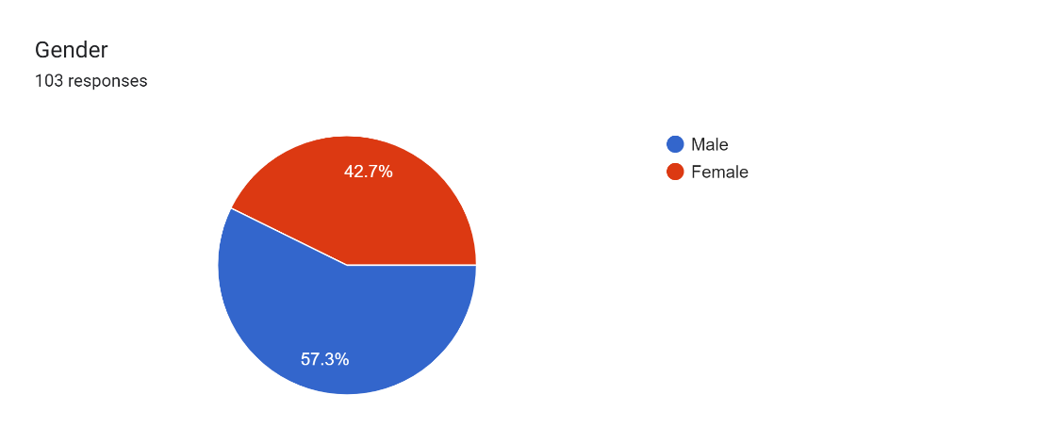

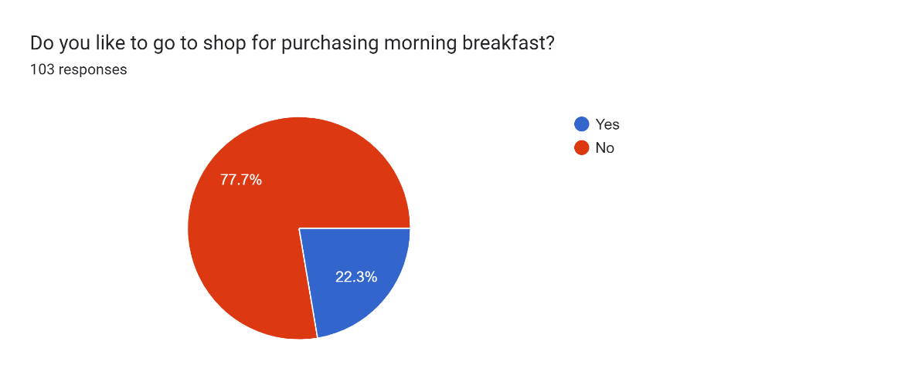

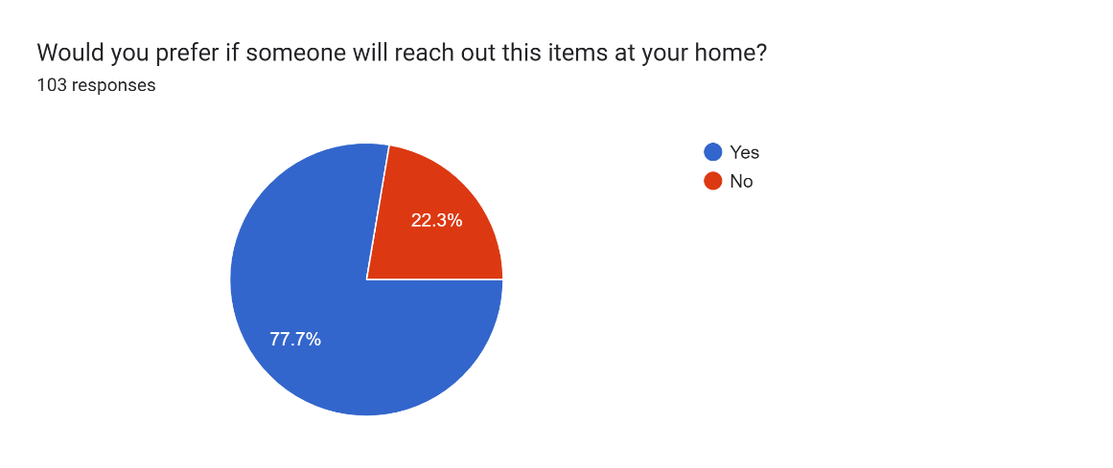

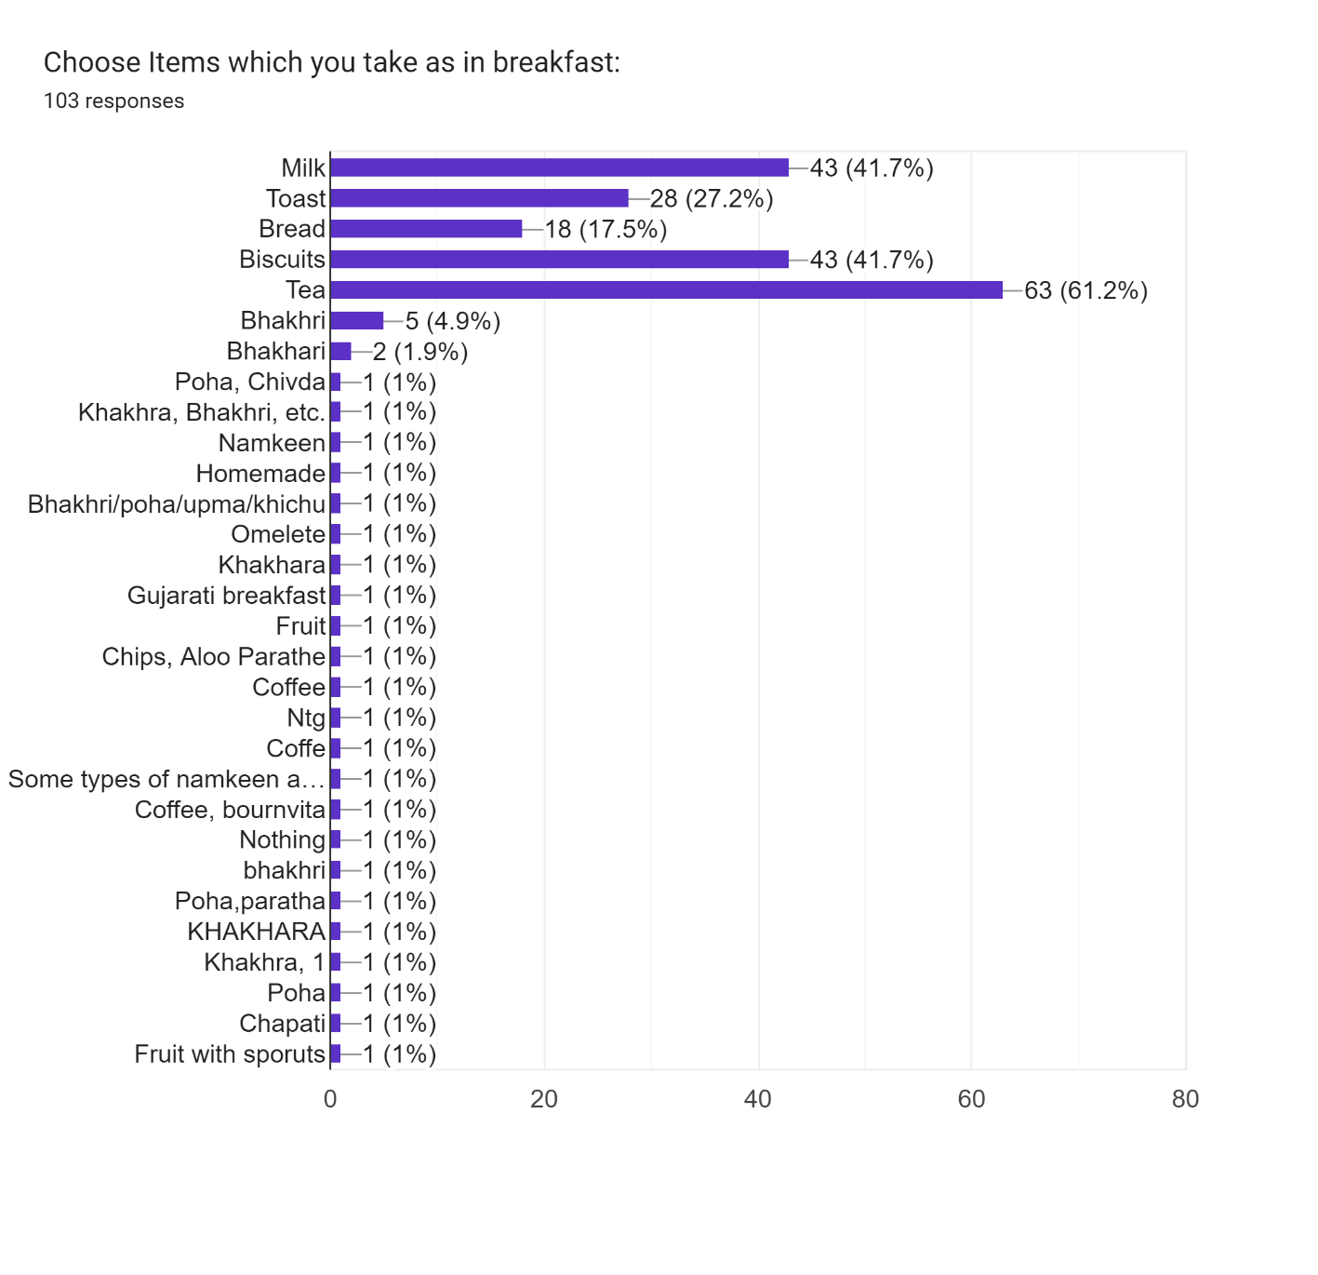

# 2.3 CONSOLIDATED LIST OF REQUIREMENTS: -

* We are creating application for making human life more straightforward and lessen their responsibility particularly for the lady at starting level.
* We are making the application which will deal with the particular classified external work by our workers. Along these lines, this is the manner by which we are making their life more straightforward.
* Our application uses modern approach for improving women’s lifestyle.
* Woman need more work balance with their personal jobs.
* All information which is shared by user To application is Totally secure and won't be shared To outsiders
* User can get the goods which they are in need of.
* User can pay for the goods through online payment option or pay the delivery person cash.

# 2.4 PROJECT DEFINITION

* The role of our app is that women are having hectic morning and they have To do a lot of work, so this app is made To give them relief, in which they have everything on their door for which she needs To go outside.
* It aims To deliver goods (dairy products etc.…) in less time and with good quality.
* As per our real data for this app research, we found that people want goods at a doorstep so their time will be saved
* User would be able To easily order goods from application
* We will assign one delivery person in every local area. And for that area, he/she will be responsible for purchasing the goods and dispatch To customer when any order comes in the app from customer. These all process will be monitored by admin at real time.
* All data which is shared by user To application is completely secure and will Not be shared To third parties.
* our main motive is To save people's time & develop application which is user friendly and easy To use.

# 3.0 SYSTEM MANAGEMENT AND PLANNING

* Developing any system for achieving the purposes the first step is analysis, planning according To requirement which we gathered from various sources and using different techniques.
* In system management and planning following thing is included.

# 3.1 FEASIBILITY STUDY

* Feasibility study is used To check whether system is feasible To develop or Not. there are many types of feasibility study available.

## 3.1.1 Technical Feasibility: -

* The project entities “Famiecare Mobile Application” is technically feasible because of the below mentioned feature. The project is developed in flutter and admin panel with html5, css3, bootstrap3&4 and MySQL.
* We have all setup environment and Tools are available To develop a system so in our system we can say that it technically feasible.

## 3.1.2 Operational Feasibility: -

* Operational feasibility study tests the operational scope of the system To be developed. It is checked that if the system is actually can be useful when it is implemented.
* Our system is operational feasible because we main focus of objective of user. And whatever operation perform on the system it is secure, reliable so we can say that our system is operational feasible.

## 3.2.3 Economic Feasibility: -

* Economic feasibility defines that whether this system is financially is feasible or Not.in economic feasibility the most important To focus on cost and maintenance of the system.
* In our system we made in Flutter.so it is less costly and if change is arrive then it easily adaptable.so it is economically feasible.

# 3.2 Hardware and Software Requirements: -

## Software Specifications: -

|  |  |
| --- | --- |
| Front-End Technology: | FLUTTER, HTML, CSS, JAVASCRIPT, BOOTSTRAP3, BOOTSTRAP4 |
| Back-End Technology: | PHP, DATABASE(MySQL) |
| Operating System: | ANY MOBILE DEVICE BUT HAVING ANDROID OR IOS AS OPERATING SYSTEM |

## Hardware Specifications: -

|  |  |
| --- | --- |
| RAM: | 2 GB Or More |
| INTERNAL STORAGE: | 500 MB |
| PROCESSOR: | SPNAPDRAGON 400, MEDIA TEK HELIO P25 |

# 

# 3.3 System Planning: -

## Work Breakdown Structure:-

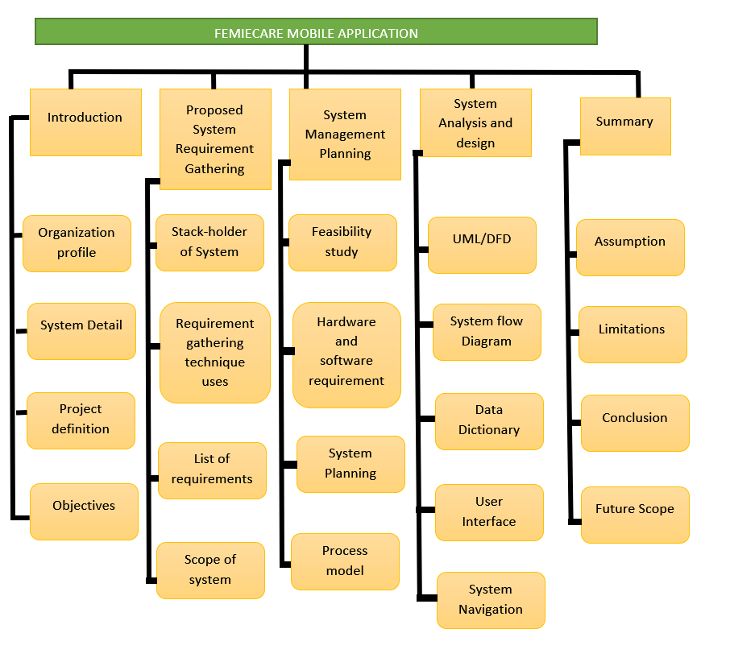

## Gantt Chart:-

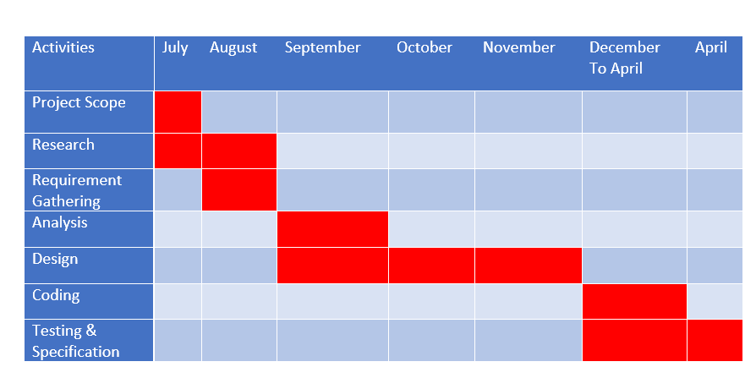

# 3.4 Process Model: -

* As per new requirements can arise in future To increment our modules that’s why we used incremental model.in every increment the needs of the client we kept in our mind and as per we delivered the features and functionality.
* Increment model is combined the elements of waterfall model but in the iterative manner.
* Incremental Model: -
* The Advantages of Incremental Model Is as Following:-

1. This model is more flexible – less costly To change scope and requirements.
2. It is easier To test, debug in a smaller iteration.
3. In this model customer can respond To each built.
4. Lowers initial delivery cost.
5. This process model helps To manage technical risks.

Diagram Of Incremental Model: -

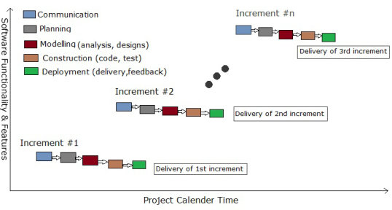

# 4.0 System Analysis And Design:-

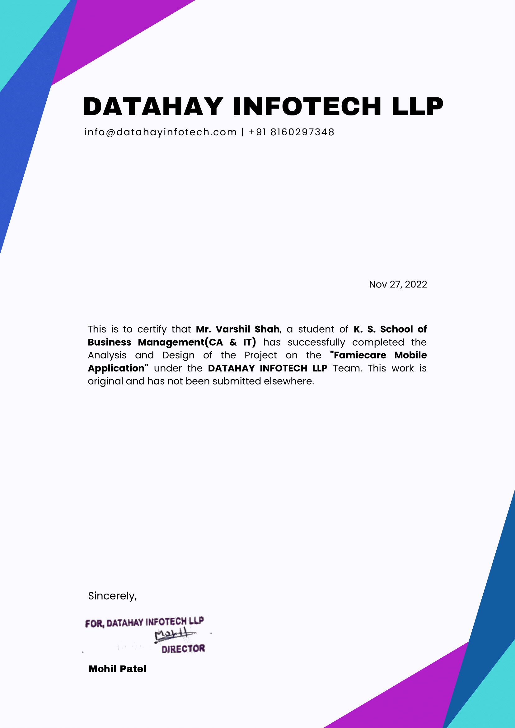

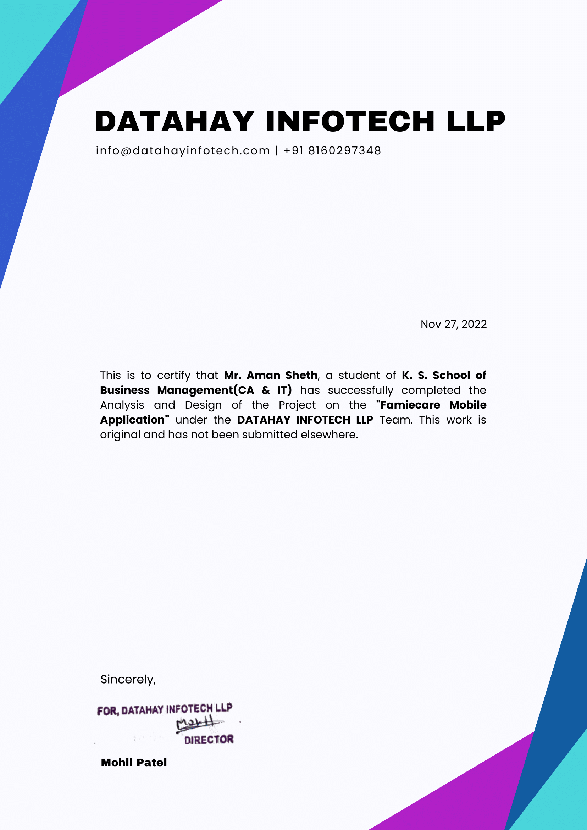

# 4.1 UML(Unified Modeling Language) Diagram:-

## Use Case Diagram:-

## For User:-

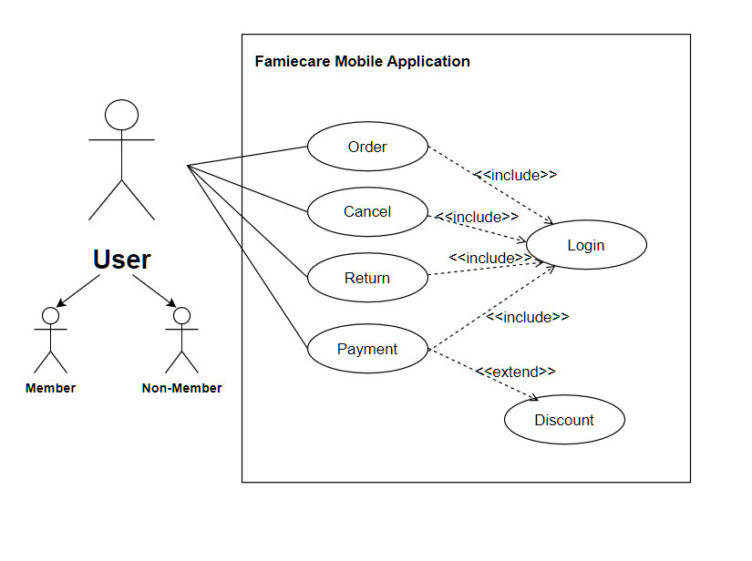

* For Delivery person:-

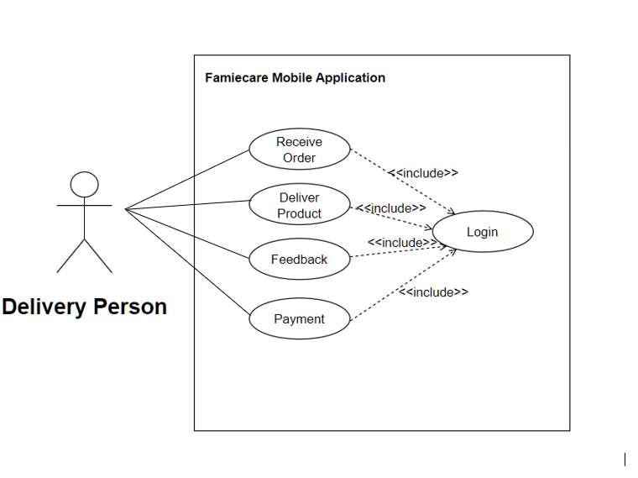

* For Admin:-

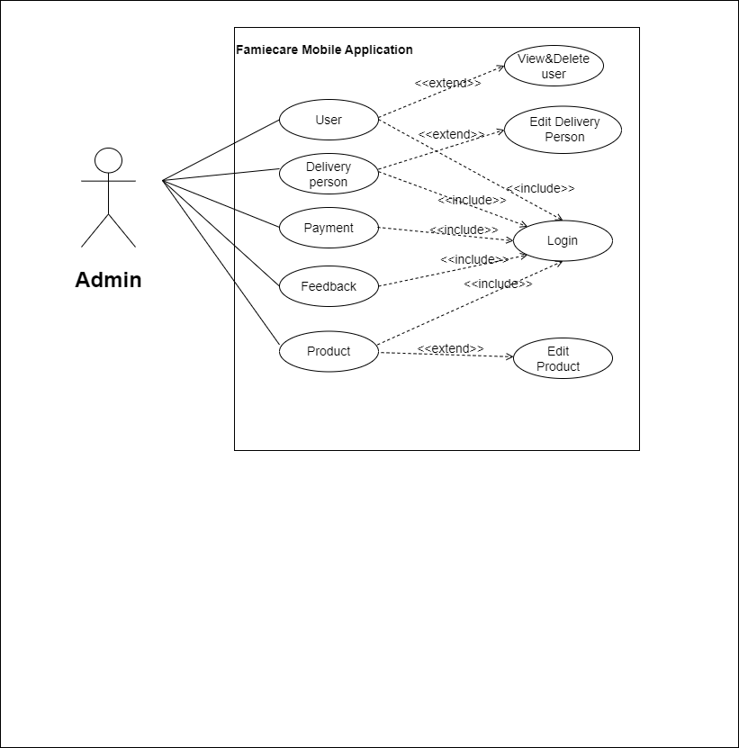

## Class Diagram:-

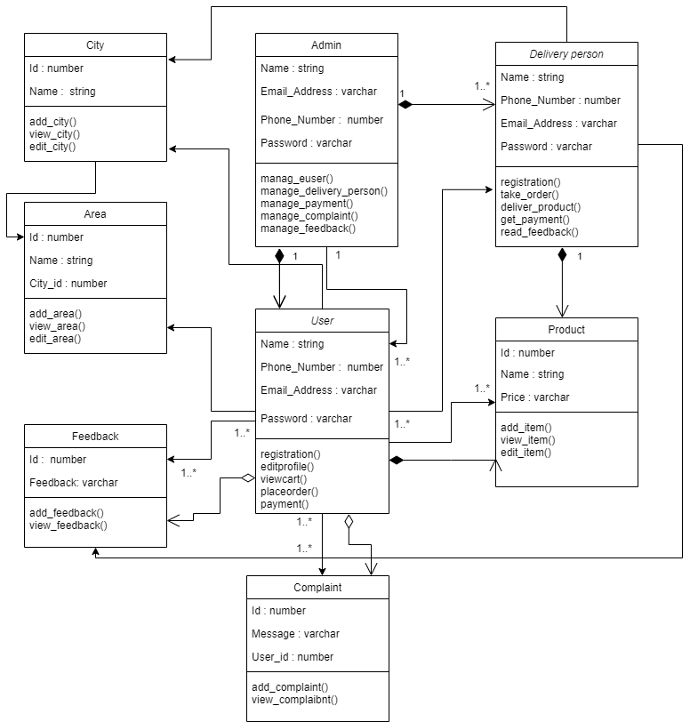

## Activity Diagram:-

## For User:-

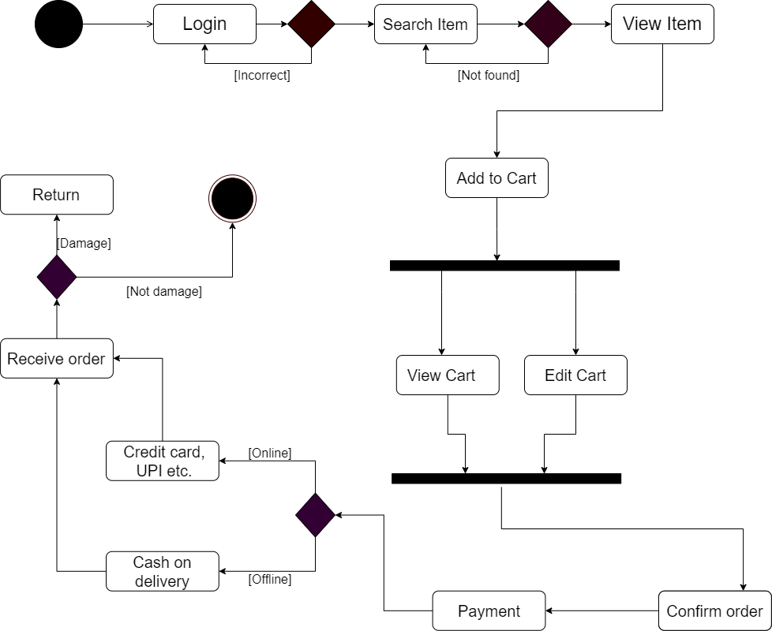

* For Admin:-

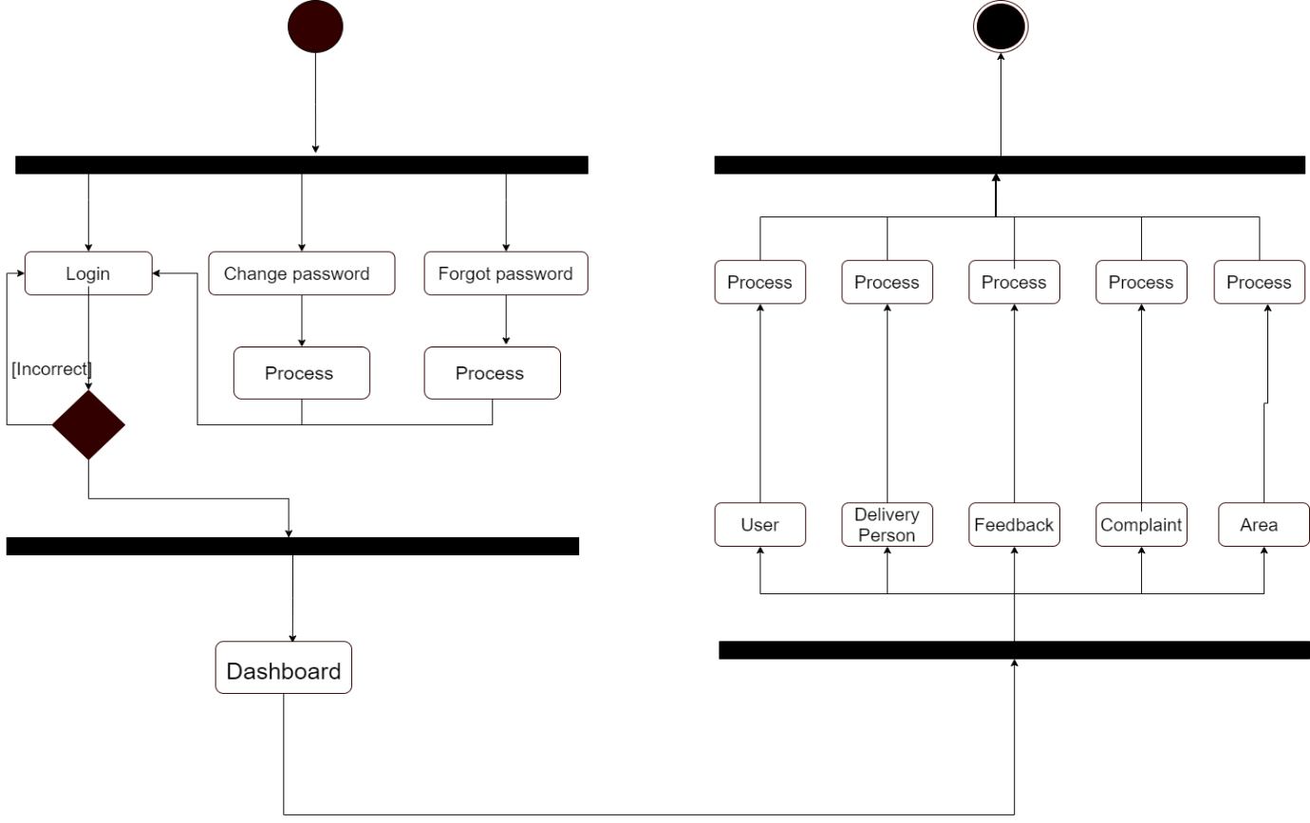

* + For Delivery person:-

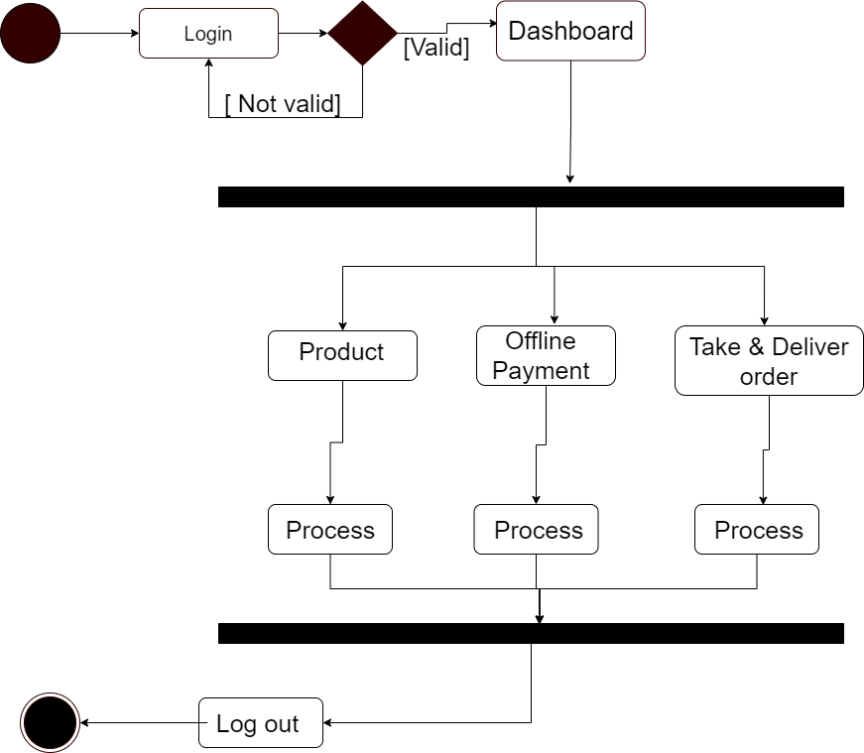

## Sequence Diagram:-

* For User:-

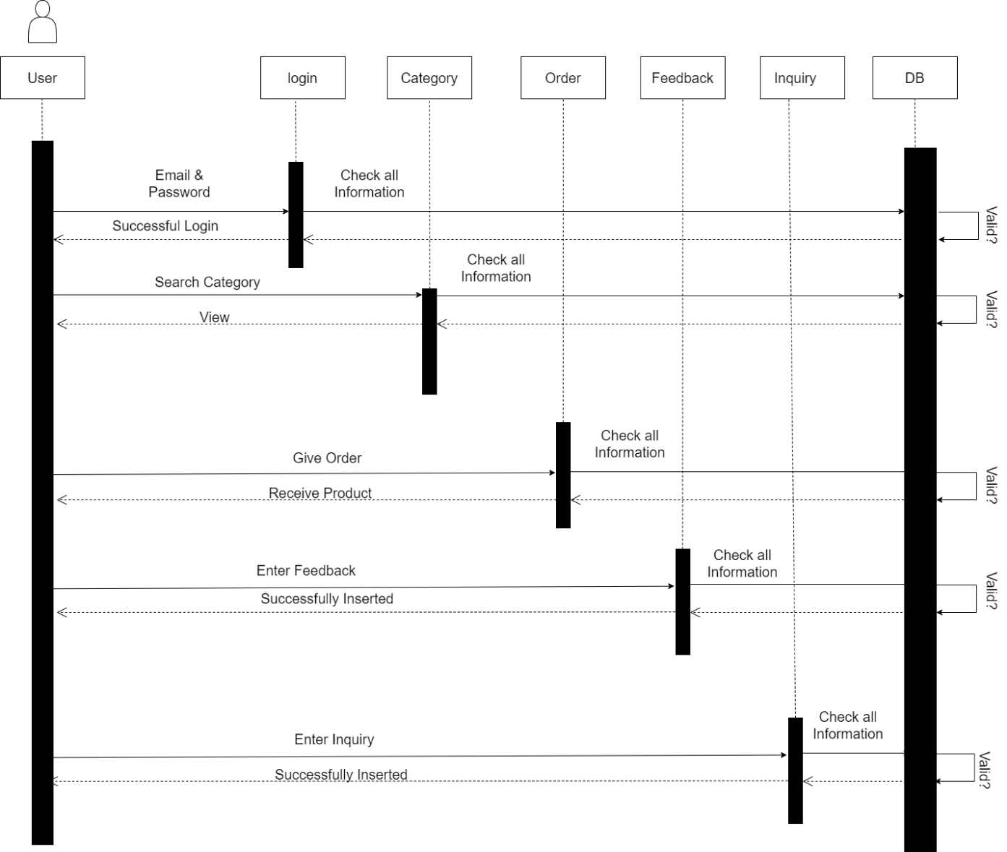

* For Delivery person:-

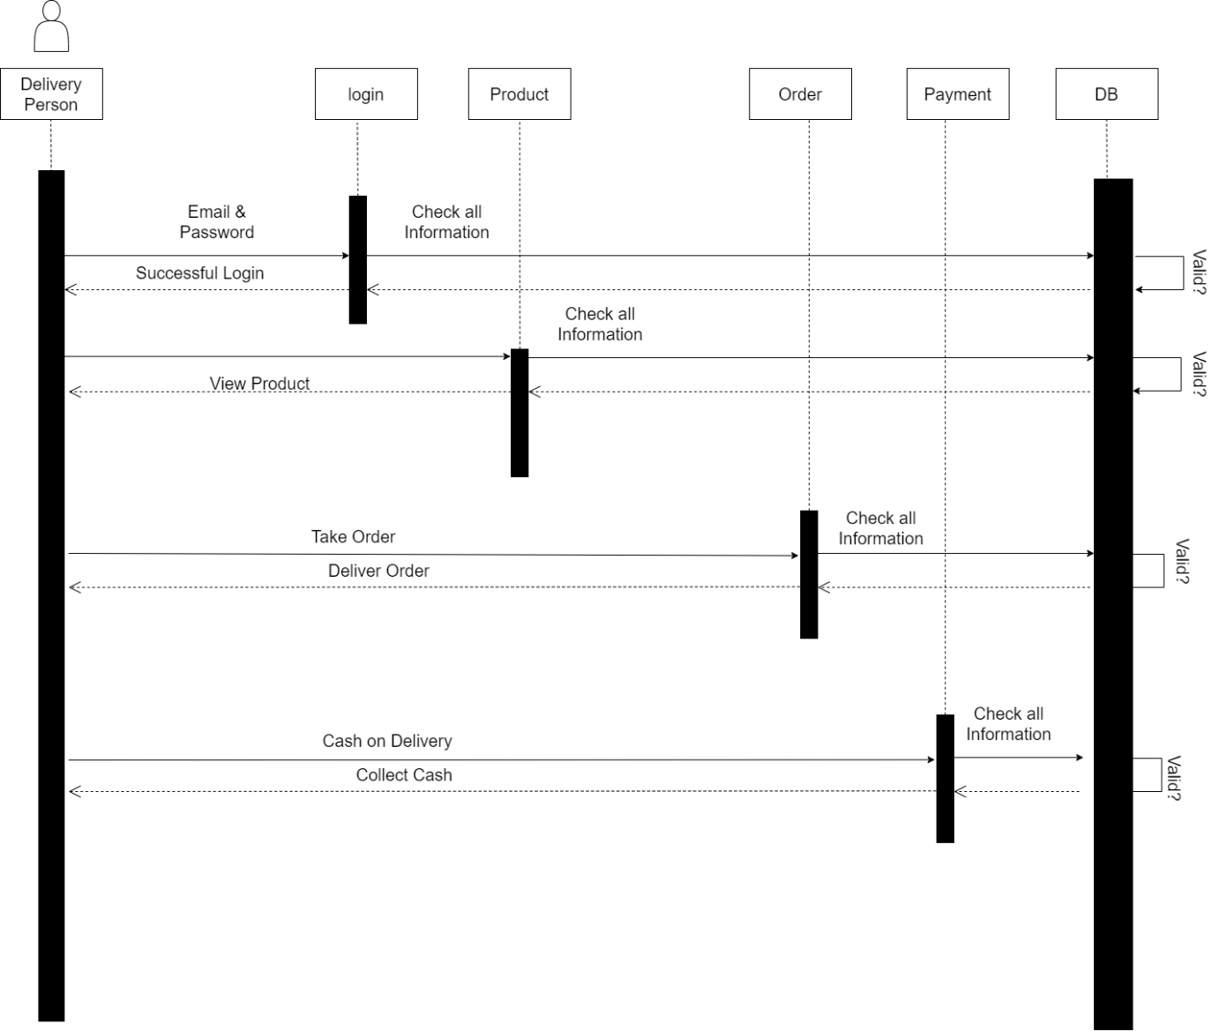

* For Admin:-

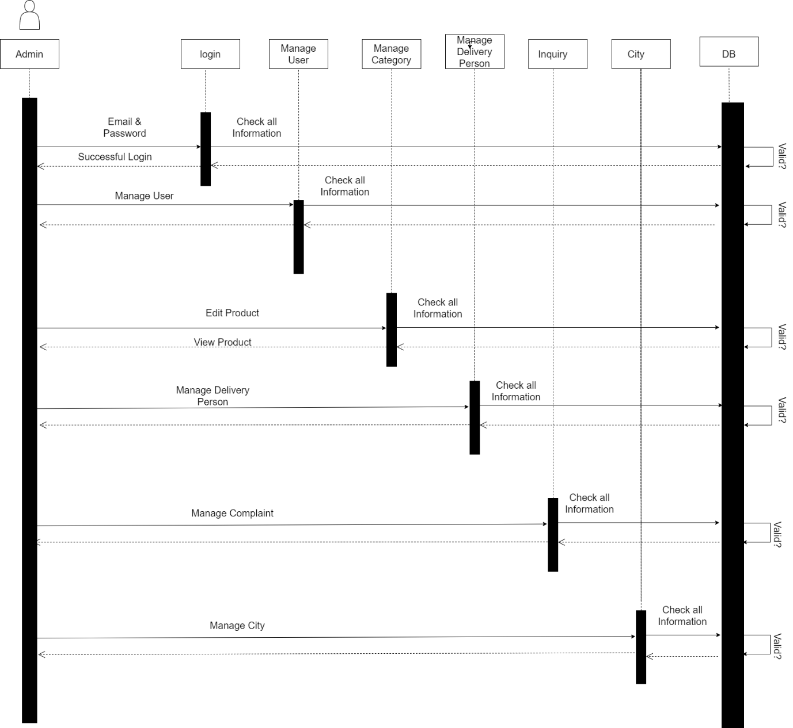

# 4.2 System Flow Diagram:-

* For Login:-

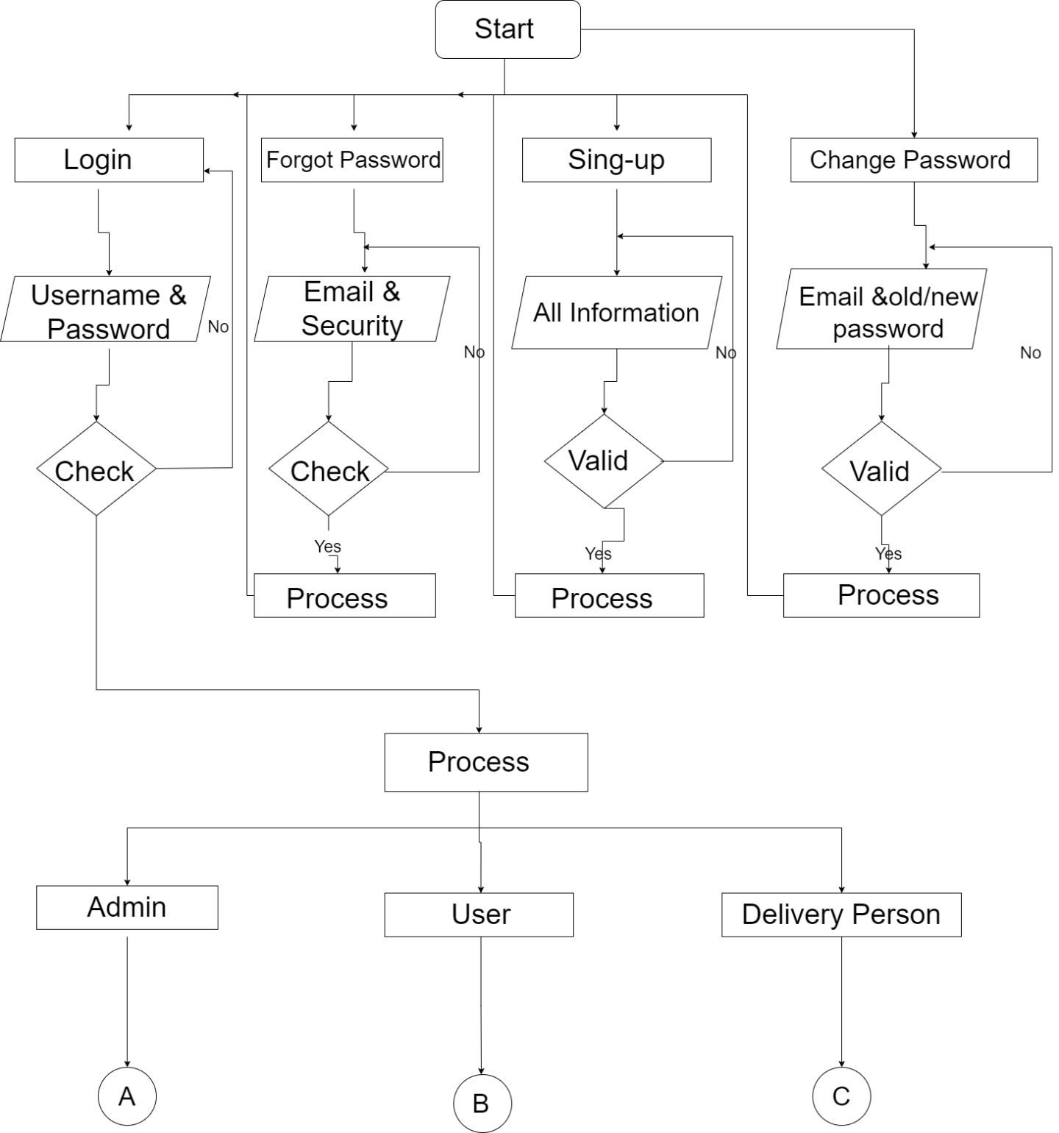

* For Admin:

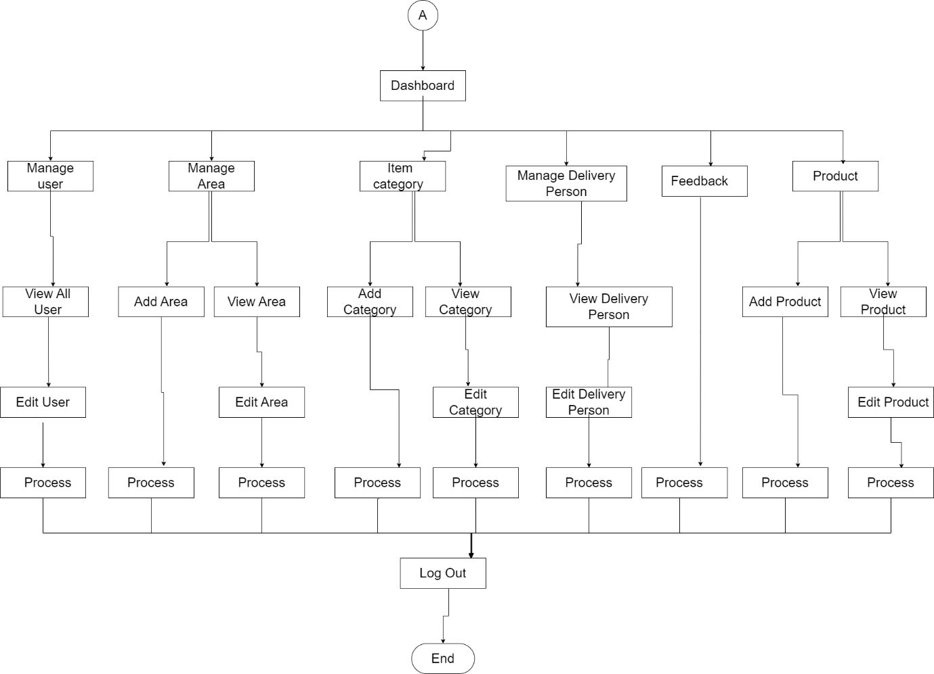

* For User:-

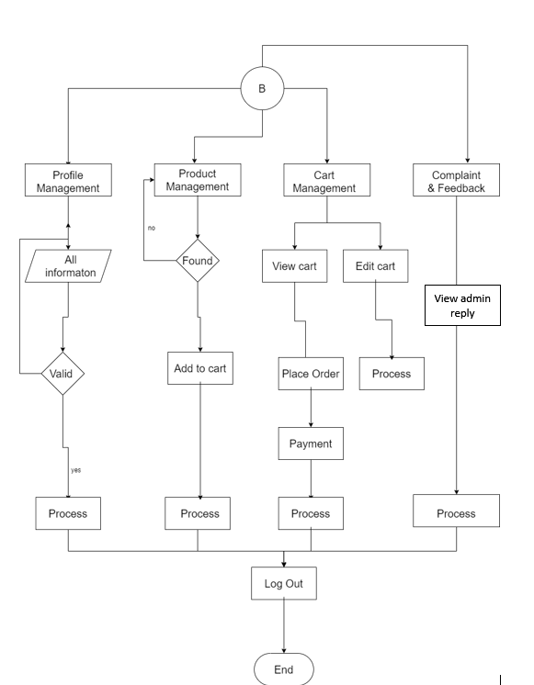

* For Delivery person:-

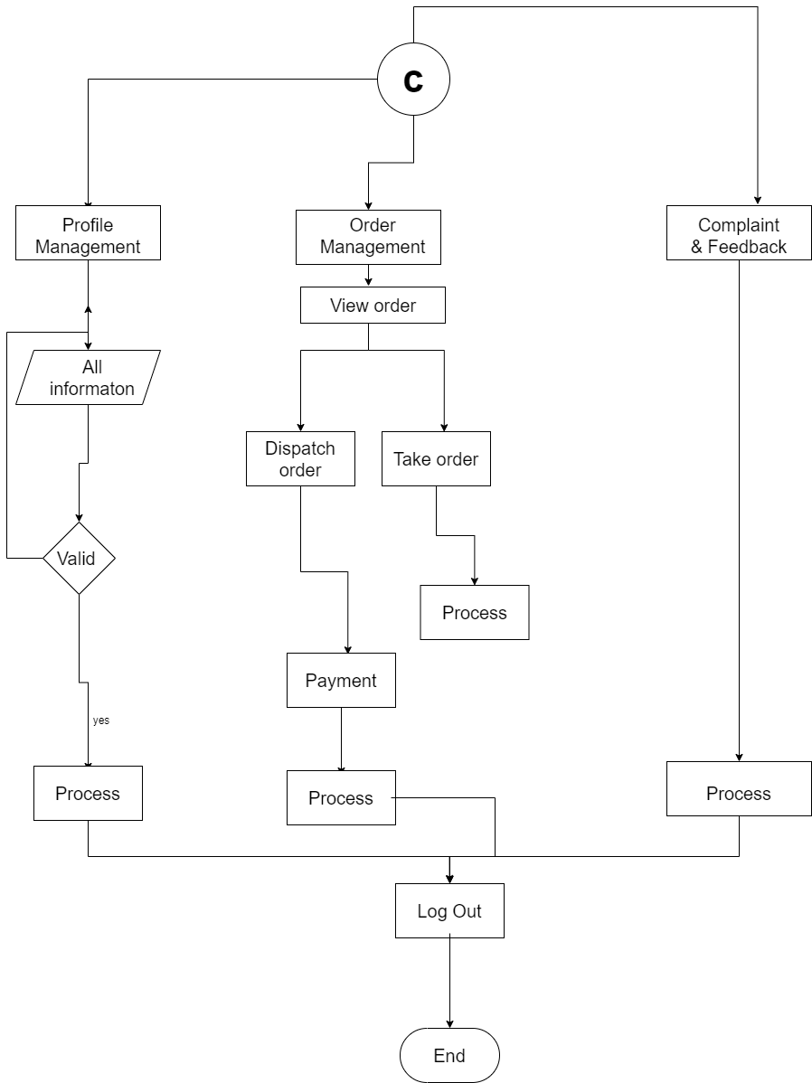

# 4.3 Data Dictionary:-

* The Data Dictionary Of Our Famiecare mobile application System Is As Below Mentioned.
* User Table:-

|  |  |  |  |  |
| --- | --- | --- | --- | --- |
| No | Field name | Data  type | Constraints | Description |
| 1 | Id | Number(5) | Primary key | Represent unique record |
| 2 | first_Name | String(20) | Not null | Represent name of the user |
| 3 | last_Name | String (20) | Not null | Represent surname od the user |
| 4 | Email | Varchar(50) | Not null | To show email address |
| 5 | Password | Varchar(20) | Not null | To show hide access of the user |
| 6 | mobile_No | Number(10) | Not null | To Represent user’s Identity |
| 7 | Gender | Varchar(10) | Not null | To Represent user’s gender |
| 8 | country_Id | Number(5) | Foreign key | To Represent relationship with country table |
| 9 | state_Id | Number(5) | Foreign key | To Represent relationship with state table |
| 10 | area_Id | Number(5) | Foreign key | To Represent relationship with area table |
| 11 | Address | Varchar(150) | Not null | Represent user’s living Identity |
| 12 | profile_Pic | Varchar(30) | Not null | Represent user’s photo |
| 13 | Security_answer | Varchar(100) | Not null | Represent user’s authentication answer |
| 14 | Security_que_Id | Number(5) | Foreign key | Represent security question table relationship |
| 15 | Doi | Date | Not null | When record inserted |
| 16 | Dou | Date | Not null | When record updated |
| 17 | Isactive | Number(1) | Not null | To identify record active or Not |
| 18 | user_Type | Varchar(15) | Not null | To represent types of users. |

* State Table:-

|  |  |  |  |  |
| --- | --- | --- | --- | --- |
| No | Field name | Data  type | Constraints | Description |
| 1 | Id | Number(5) | Primary key | Uniquely Identification |
| 2 | state_Name | String (20) | Not null | Represent state name |
| 3 | Isactive | Number(1) | Not null | Verify record is active or Not |
| 4 | Doi | Date | Not null | To show on which Date recorded is inserted |
| 5 | Dou | Date | Not null | To show on which Date record is updated |

* City Table:-

|  |  |  |  |  |
| --- | --- | --- | --- | --- |
| No | Field name | Data  type | Constraints | Description |
| 1 | Id | Number(5) | Primary key | Uniquely Identification |
| 2 | city_Name | String (20) | Not null | Represent city name |
| 3 | Isactive | Number(1) | Not null | Verify record is active or Not |
| 4 | Doi | Date | Not null | To show on which Date recorded is inserted |
| 5 | Dou | Date | Not null | To show on which Date record is updated |
| 6 | state_Id | Number(5) | Foreign key | To Represent state table relationship |

* Brand Table:-

|  |  |  |  |  |
| --- | --- | --- | --- | --- |
| No | Field name | Data  type | Constraints | Description |
| 1 | Id | Number(5) | Primary key | Uniquely Identification |
| 2 | brand_Name | varchar(20) | Not null | Represent city name |
| 3 | Isactive | Number(1) | Not null | verify record is active or Not |
| 4 | Doi | Date | Not null | To show on which Date recorded is inserted |
| 5 | Dou | Date | Not null | To show on which Date record is updated |
| 6 | brand_Img | Varchar (5) | Not null | To Represent pic of different category |

* Area Table:-

|  |  |  |  |  |
| --- | --- | --- | --- | --- |
| No | Field name | Data  type | Constraints | Description |
| 1 | Id | Number(5) | Primary key | Uniquely Identification |
| 2 | area_Name | String (20) | Not null | To Represent area name |
| 3 | Isactive | Number(1) | Not null | To verify record is active or Not |
| 4 | Doi | Date | Not null | To show on which Date recorded is inserted |
| 5 | Dou | Date | Not null | To show on which Date record is updated |
| 6 | city_Id | Number(5) | Foreign key | To Represent city table relationship |

* Sub Product Table:-

|  |  |  |  |  |
| --- | --- | --- | --- | --- |
| No | Field name | Data  type | Constraints | Description |
| 1 | Id | Number(5) | Primary key | Uniquely Identification |
| 2 | catagory_Name | varchar(20) | Not null | To Represent item category name |
| 3 | category_Pic | varchar(20) | Not null | To Represent pic of different category |
| 4 | Isactive | Number(1) | Not null | To verify record is active or Not |
| 5 | Doi | Date | Not null | To show on which Date recorded is inserted |
| 6 | Dou | Date | Not null | To show on which Date record is updated |

* Product Table:-

|  |  |  |  |  |
| --- | --- | --- | --- | --- |
| No | Field name | Data  type | Constraints | Description |
| 1 | Id | Number(5) | Primary key | Uniquely Identification |
| 2 | product_Name | varchar(20) | Not null | To Represent item name |
| 3 | product_Pic | varchar(20) | Not null | To Identify image of item |
| 4 | product_Price | Number(10) | Not null | To Represent price of item |
| 5 | Isactive | Number(1) | Not null | To verify record is active or Not |
| 6 | Doi | Date | Not null | To show on which Date recorded is inserted |
| 7 | Dou | Date | Not null | To show on which Date record is updated |

* Feedback Table:-

|  |  |  |  |  |
| --- | --- | --- | --- | --- |
| No | Field name | Data  type | Constraints | Description |
| 1 | Id | Number(5) | Primary key | Uniquely Identification |
| 2 | feedback | varchar(200) | Not null | To Represent feedback from user side for a functionary. |
| 3 | user_Id | Number(5) | Foreign key | To Represent relationship with user table |

* User Type Table:-

|  |  |  |  |  |
| --- | --- | --- | --- | --- |
| No | Field name | Datatype | Constraints | Description |
| 1 | Id | Number(5) | Primary key | Uniquely Identification |
| 2 | type_Name | varchar(200) | Not null | To Represent user name |
| 3 | Isactive | Number(1) | Not null | To verify record is active or Not |

* Complaint Table:-

|  |  |  |  |  |
| --- | --- | --- | --- | --- |
| No | Field name | Data  type | Constraints | Description |
| 1 | Id | Number(5) | Primary key | Uniquely Identification |
| 2 | complaint | Varchar(200) | Not null | To Represent complain about seller or customer |
| 3 | user_Id | Number(5) | Foreign key | To Represent relationship with user table |

* Security Question Table:-

|  |  |  |  |  |
| --- | --- | --- | --- | --- |
| No | Field name | Data  type | Constraints | Description |
| 1 | Id | Number(5) | Primary key | Uniquely Identification |
| 2 | question | Varchar(100) | Not null | To Represent the different types of security question |

* Payment Table:-

|  |  |  |  |  |
| --- | --- | --- | --- | --- |
| No | Field name | Data  type | Constraints | Description |
| 1 | order_Id | Number(5) | Primary key | Uniquely Identification |
| 2 | order_Name | Varchar(50) | Not null | To Represent order name which order by the buyer |
| 3 | Isactive | Number(1) | Not null | To verify record is active or Not |
| 4 | Doi | Date | Not null | To show on which Date recorded is inserted |
| 5 | Dou | Date | Not null | To show on which Date record is updated |
| 6 | product_Id | Number(5) | Foreign key | To Represent relationship with item table |

# 4.4 User Interface:-

## Sign-In Page:-

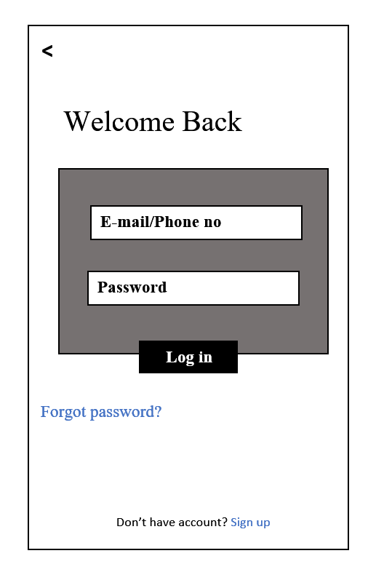

## Sign-up Page(1):-

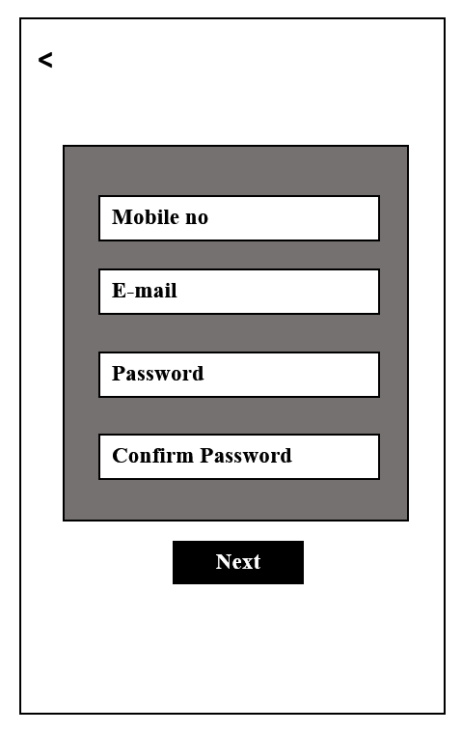

## Sign-up Page(2):-

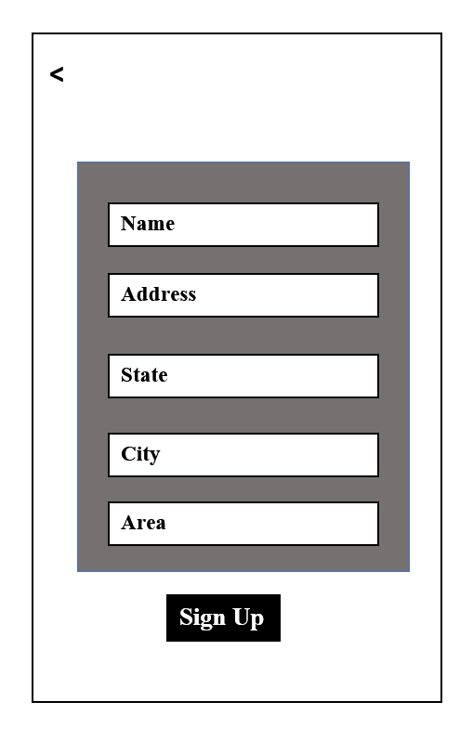

## Home page:-

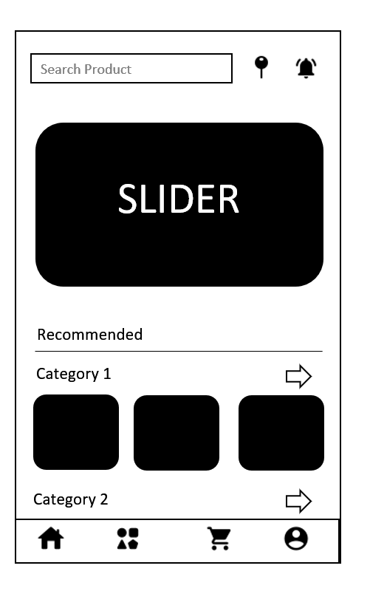

## Payment:-

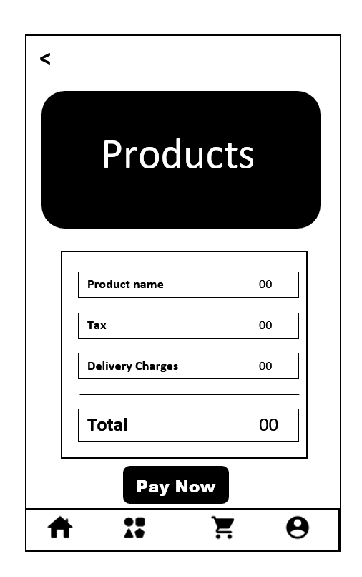

## Admin Panel:-

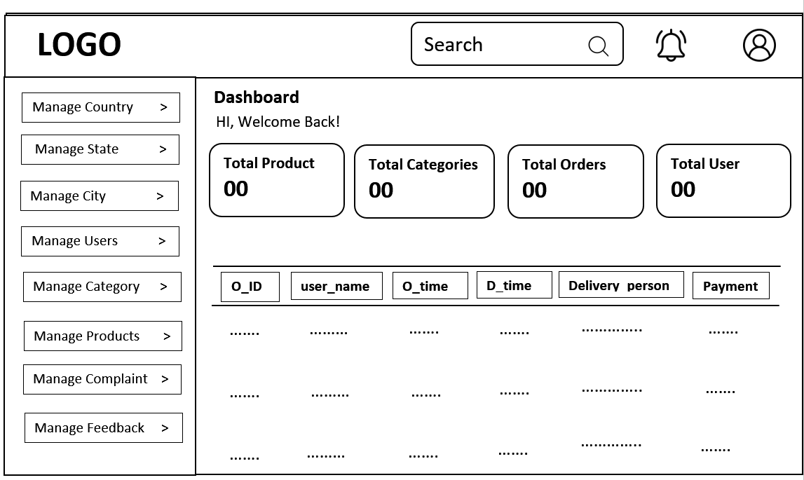

# LIMITATIONS:-

* Currently we target one city.
* Required internet connection.
* We accept cash om delivery for now on.

# BIBLIOGRAPHY:-

1. <https://www.youtube.com/@5MinutesEngineering>
2. <https://www.youtube.com/playlist?list=PLjVLYmrlmjGfGLShoW0vVX_tcyT8u1Y3E>
3. <https://www.youtube.com/watch?v=R2sRhDq7qKk&ab_channel=GeekyShows>
4. <https://www.youtube.com/watch?v=Ej_Pcr4uC2Q&ab_channel=freeCodeCamp.org>
5. <https://www.youtube.com/playlist?list=PLYwpaL_SFmcD1pjNSpEm2pje3zPrSiflZ>
6. <https://www.youtube.com/playlist?list=PLYwpaL_SFmcD1pjNSpEm2pje3zPrSiflZ>
7. <https://www.geeksforgeeks.org/unified-modeling-language-uml-sequence-diagrams/>
8. <https://www.draw.io/index.html>
9. <https://chat.openai.com>

# EVALUTION FORM

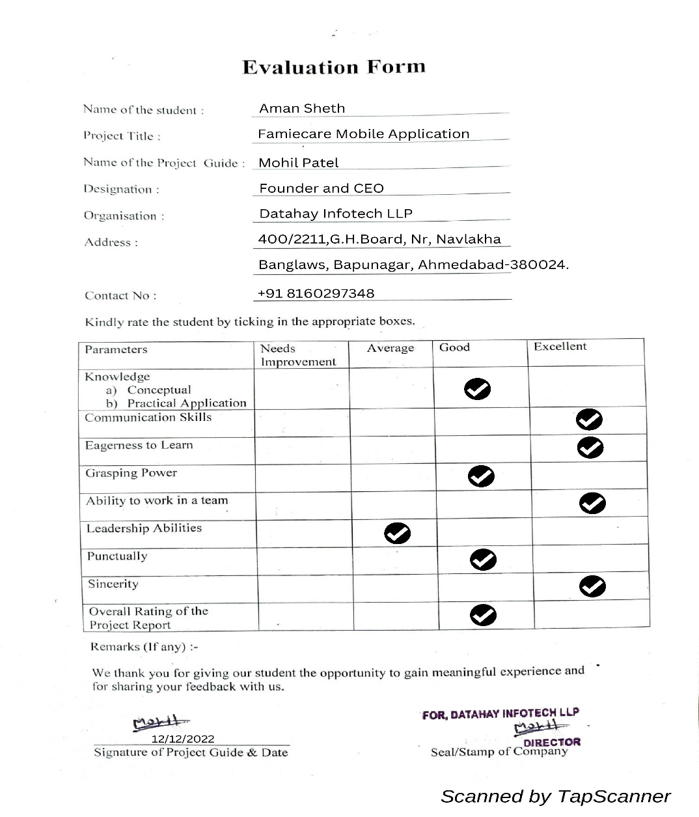

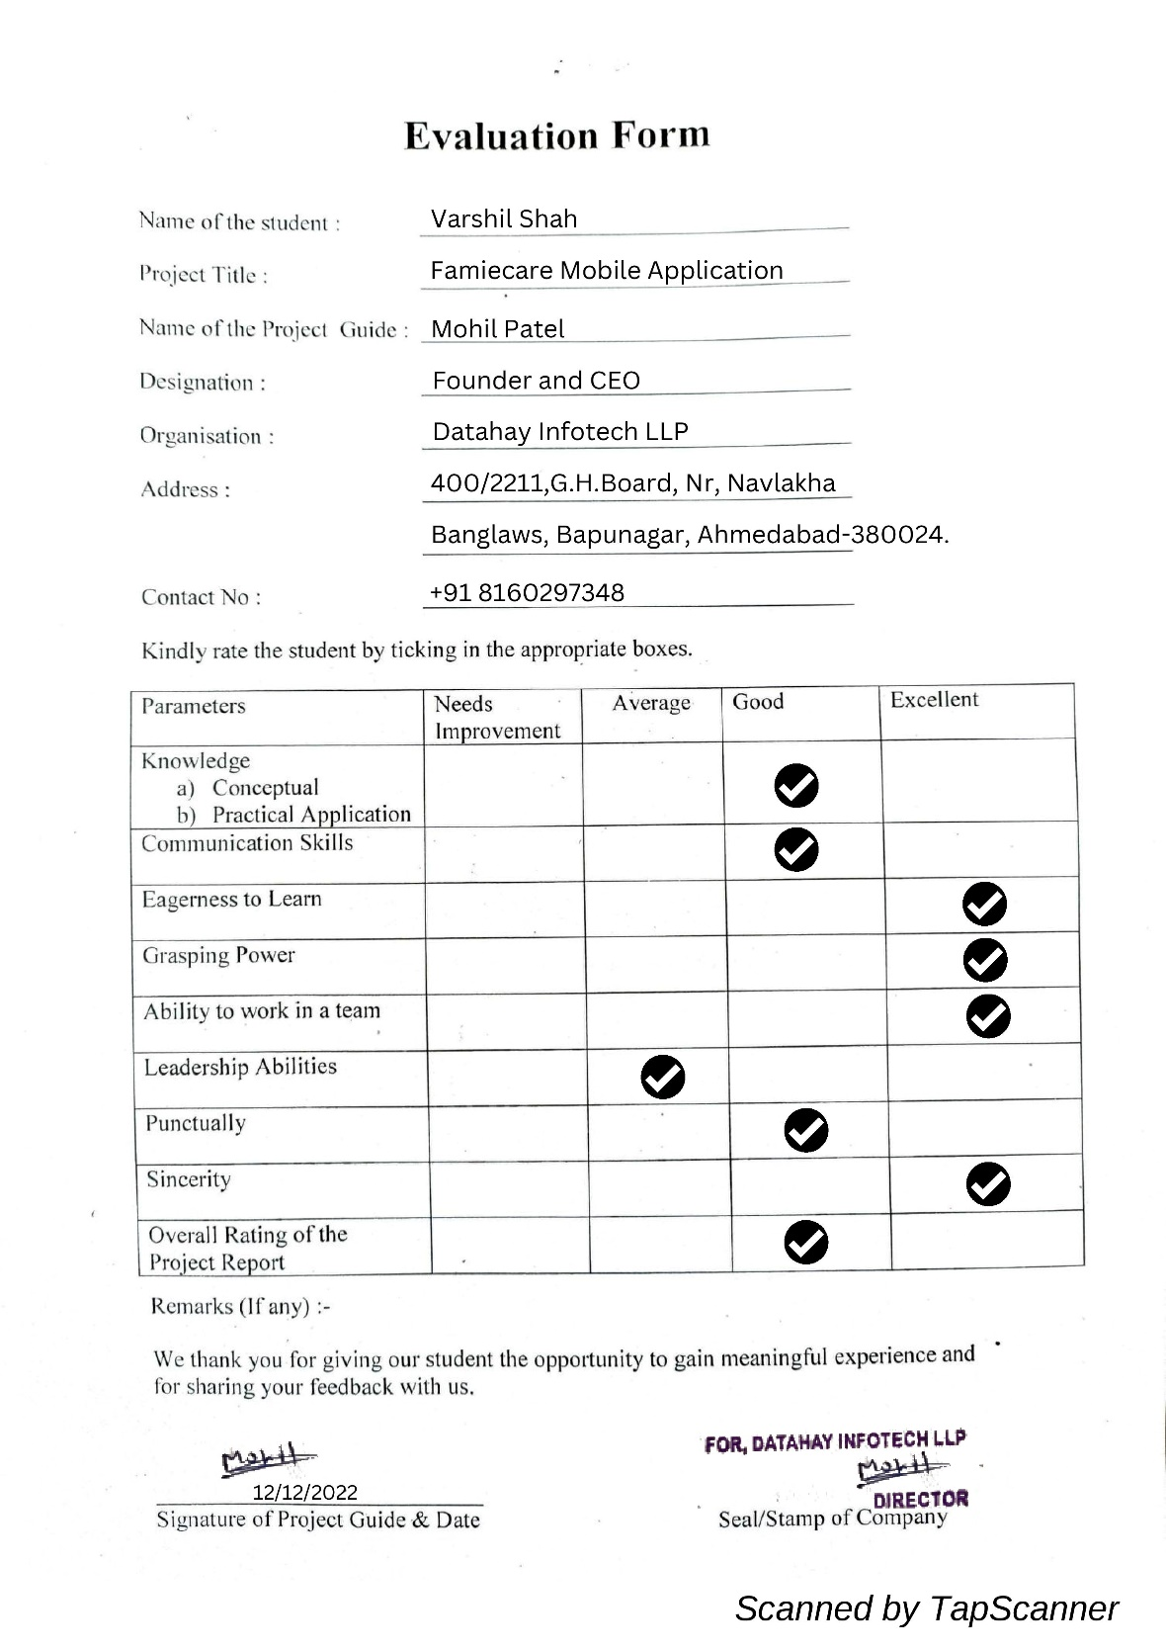

5.INPUT OUTPUT DESIGN

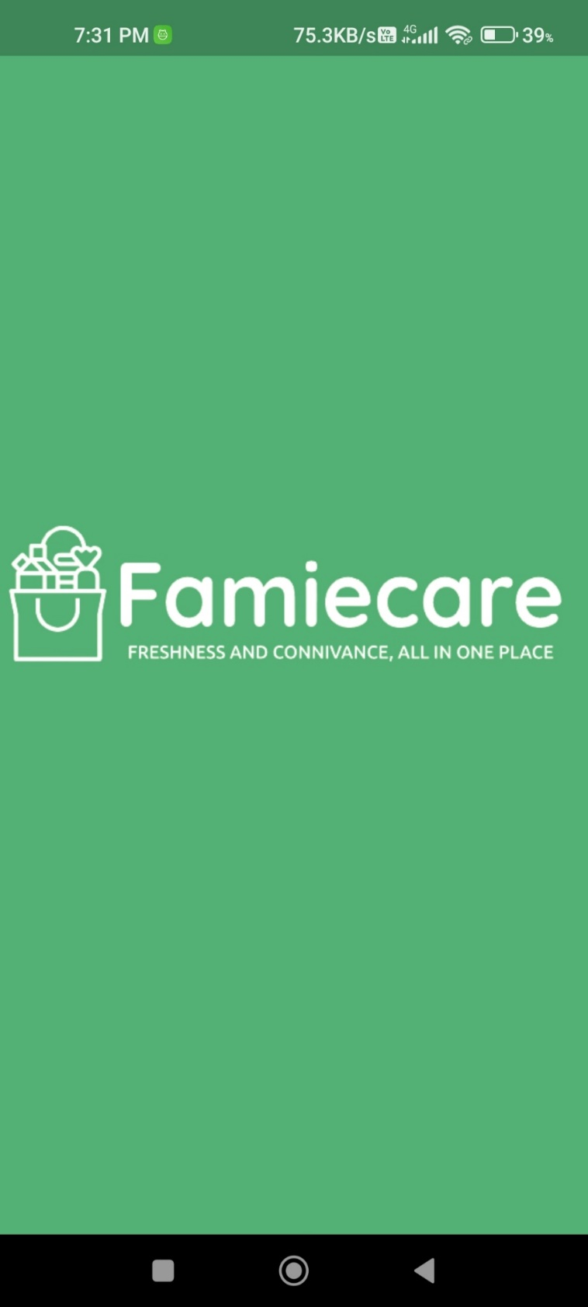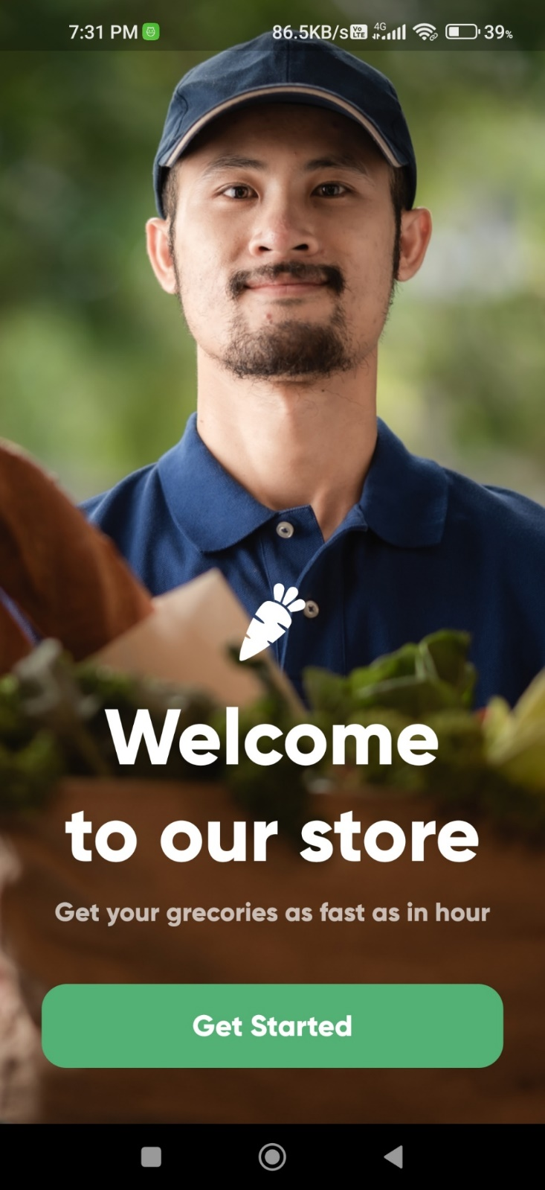

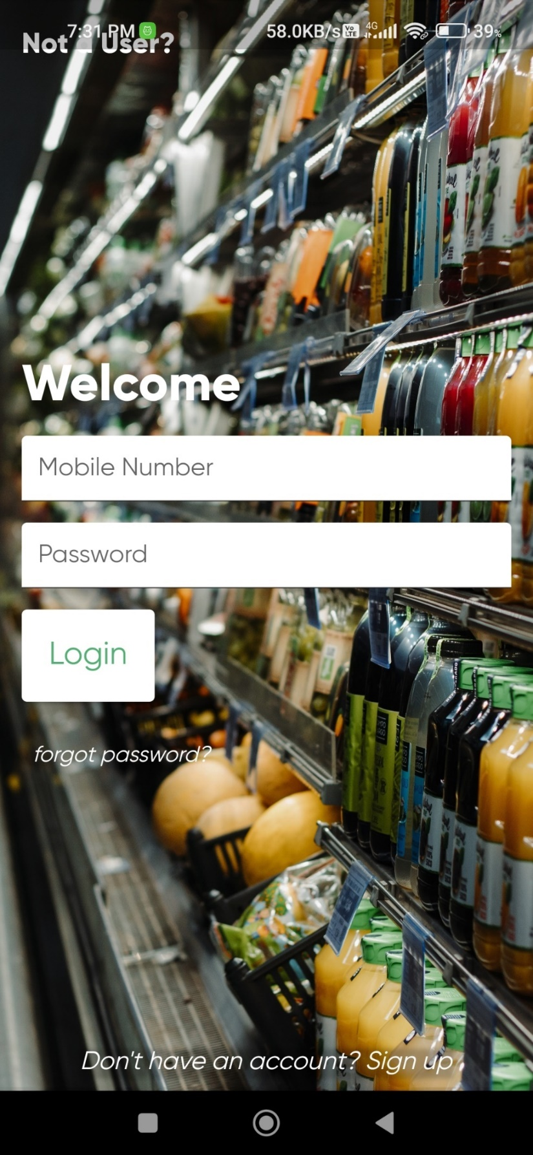–––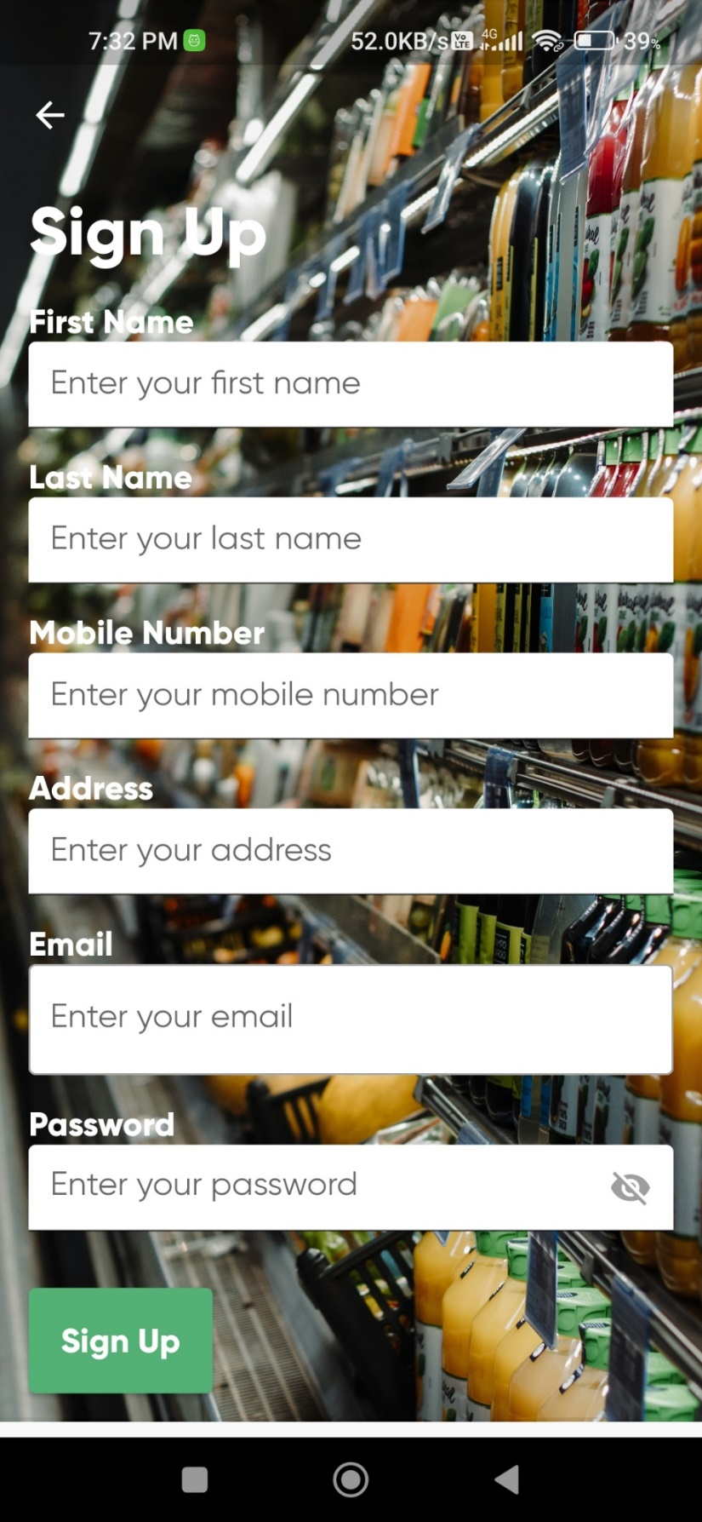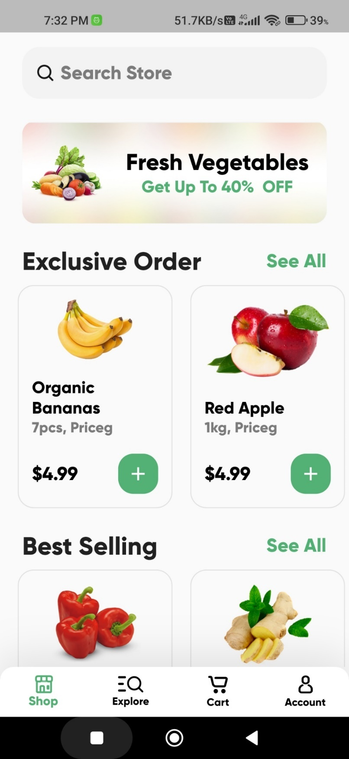-––––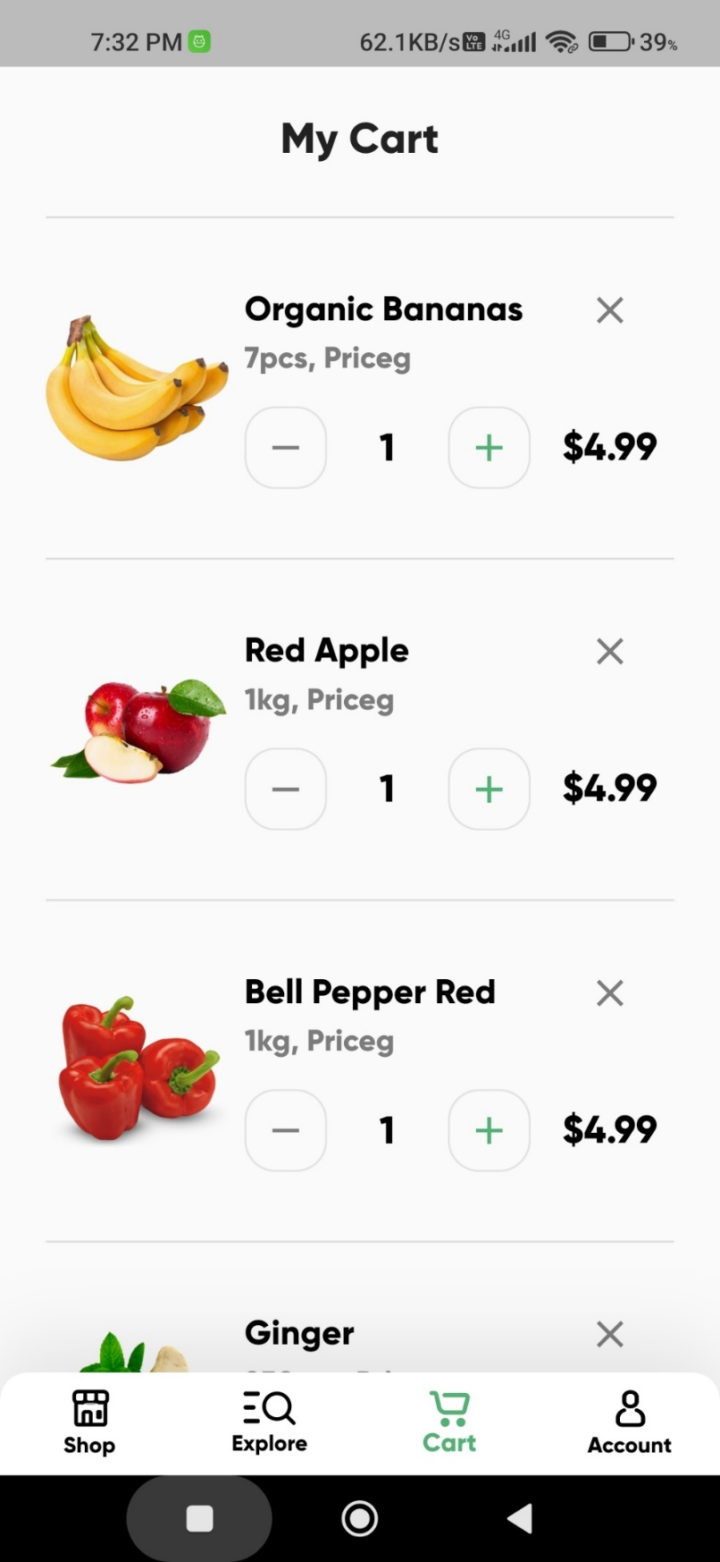––––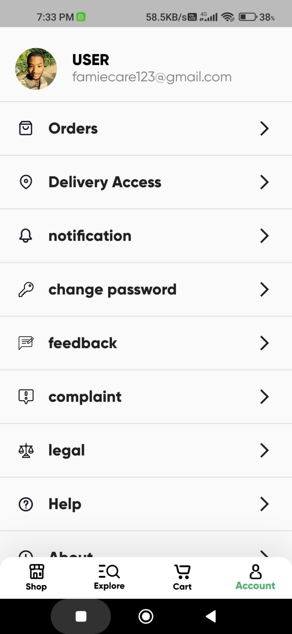

## Admin Panel

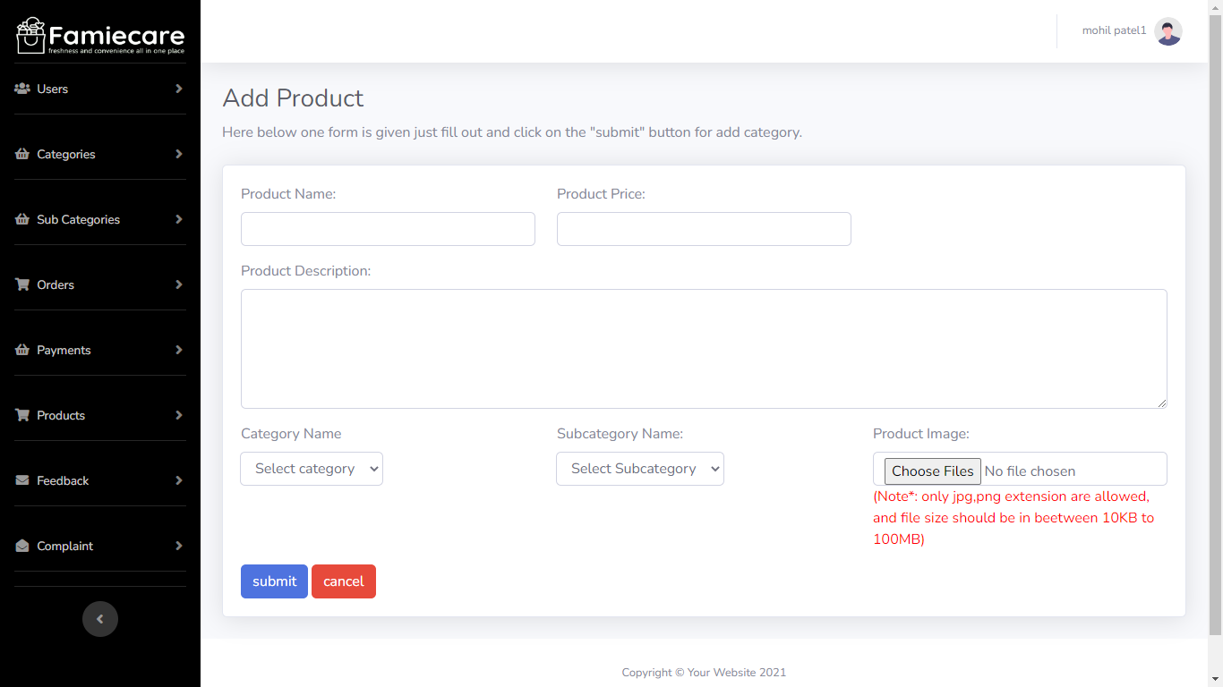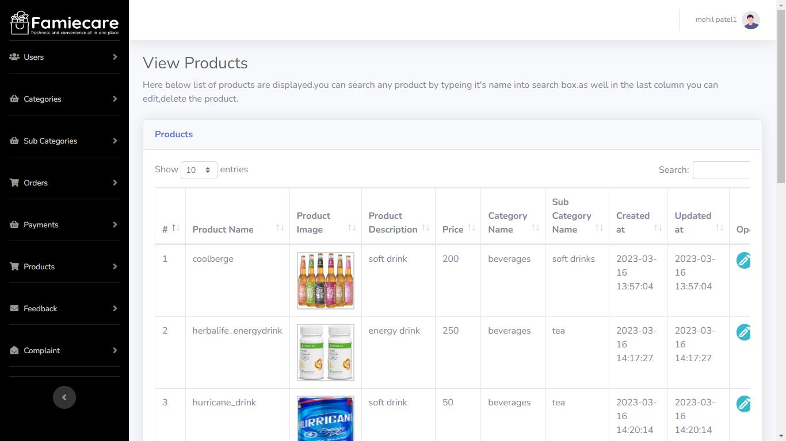

6.Testing

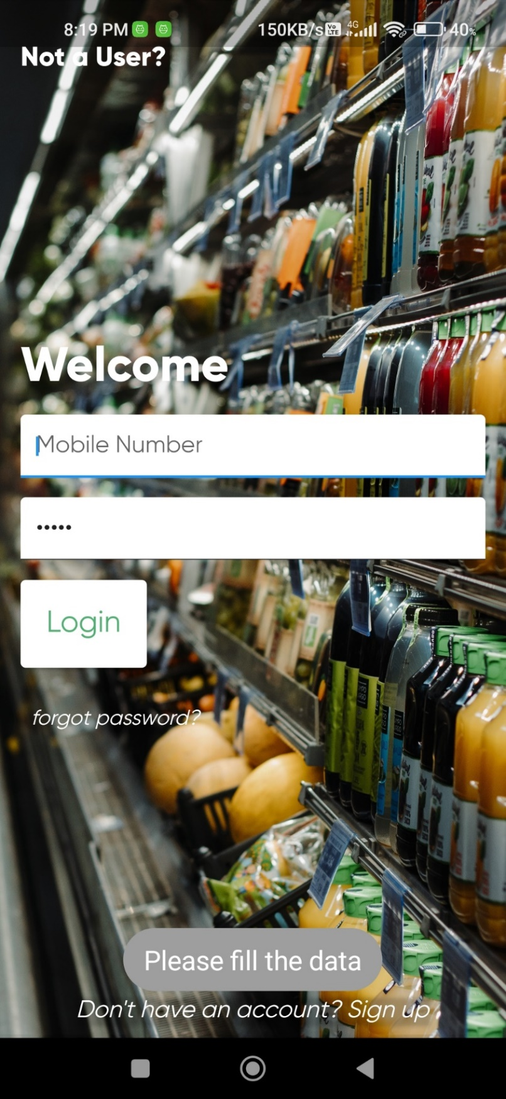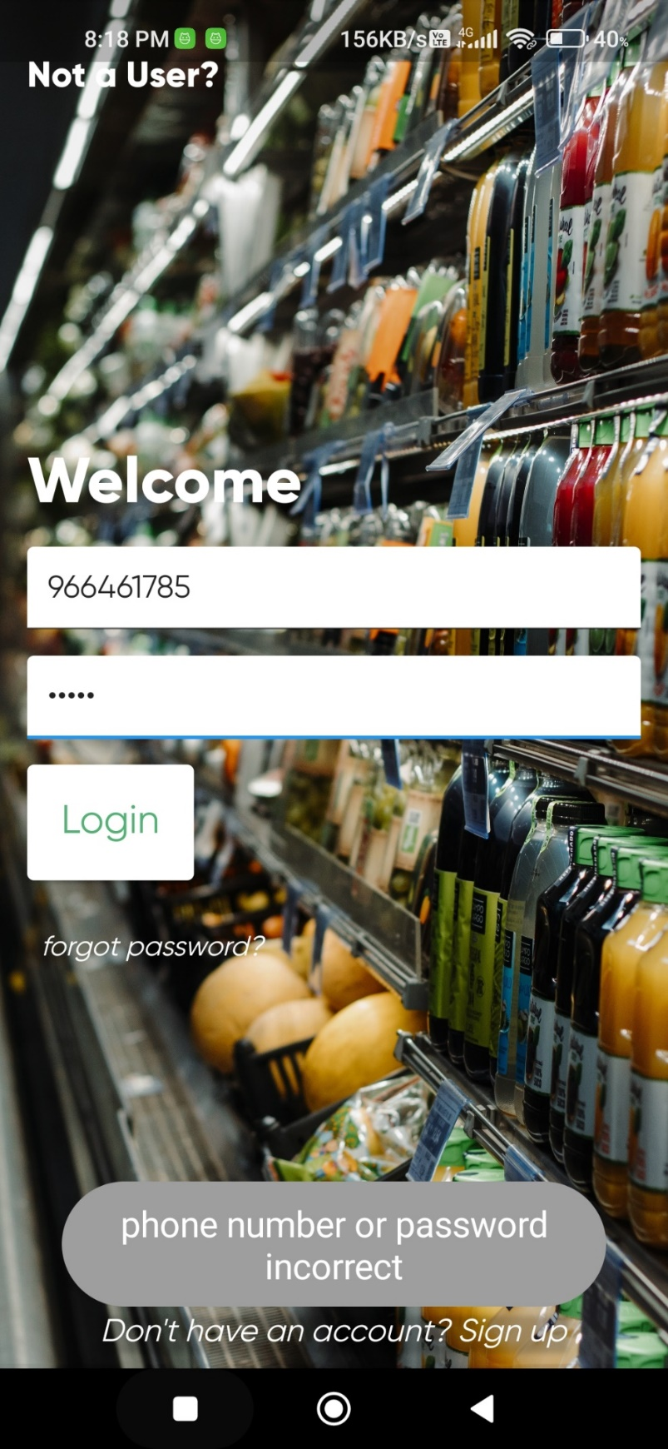

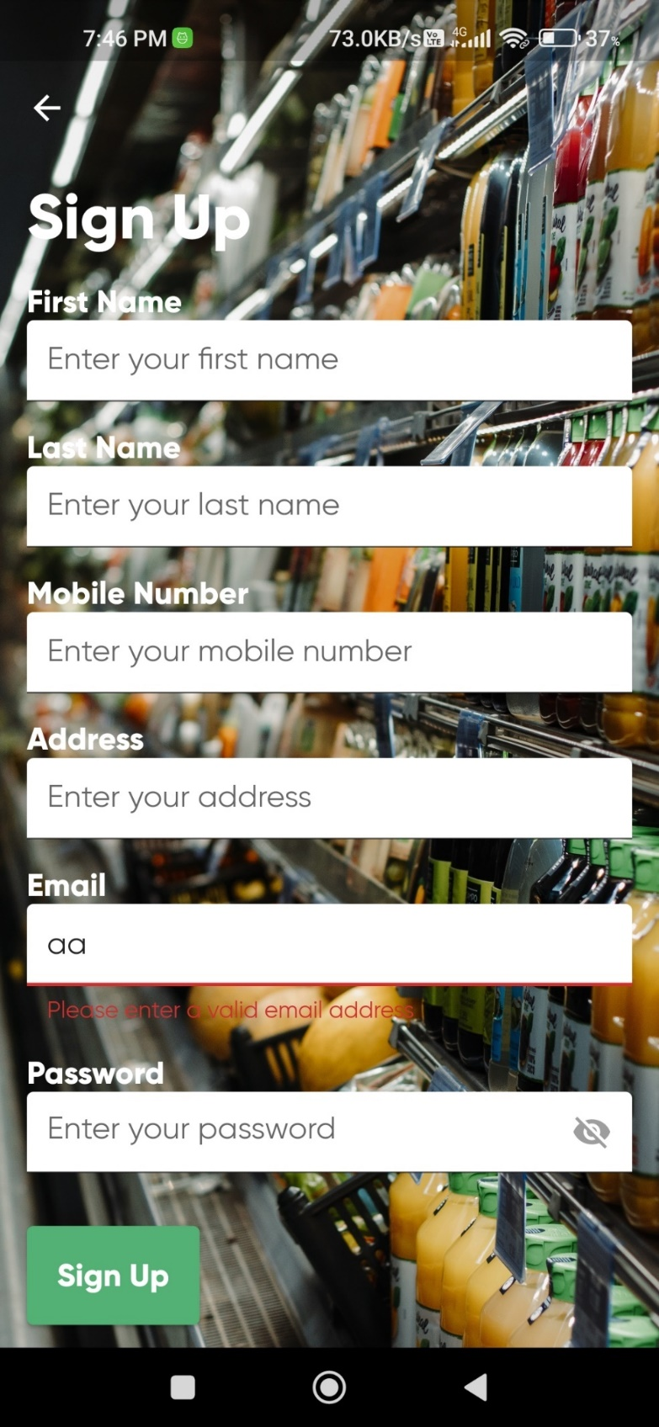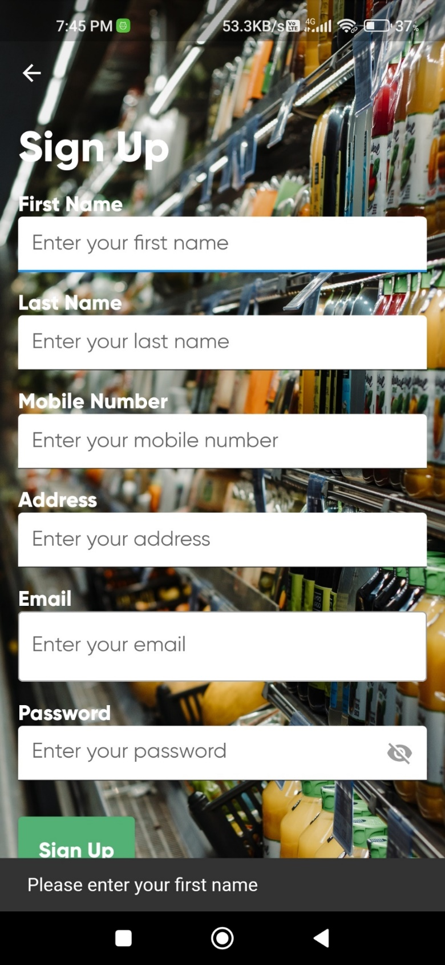

7.Summary

## 7.1 Assumptions

➔ The Client should have basic knowledge of how mobile applications work.

➔ They must have a valid email id or phone number for signing up and logging in.

➔ The mobile device should have a stable internet connection and be compatible with the app.

## 7.2 Limitations

➔ The Famiecare grocery mobile application is currently limited to providing services within specific geographical areas.

## 7.3 Future Scope

➔ Continuous improvement in the user experience by incorporating feedback and introducing new features.

➔ Expansion of the Famiecare grocery mobile application to serve other cities and regions.

➔ Integration of live chat support between users and customer service representatives for real-time assistance.

## 7.4 Conclusion

➔ The Famiecare grocery mobile application aims to bridge the gap between consumers and grocery providers, offering a convenient and seamless shopping experience. With this app, users can easily place orders, manage their grocery lists, and access exclusive deals from local stores. The platform also enables grocery providers to expand their reach, reduce waste, and better serve their customers.

➔ By continuously improving the application based on user feedback and incorporating advanced features, Famiecare will save users and grocery providers valuable time, making grocery shopping more efficient and enjoyable.

# EVALUTION FORM

